## COURSE 6 - SHARE DATA THROUGH THE ART OF VISUALIZATION

## MODULE 1

In this module, you’ll delve into the various types of data visualizations and explore what makes an effective visualization. You'll also learn about accessibility, design thinking, and other factors that will help you use data visualizations to effectively communicate data insights.

### Learning Objectives

* Explain the key concepts involved in design thinking as they relate to data visualization
* Describe the use of data visualizations to talk about data and the results of data analysis
* Discuss accessibility issues associated with data visualization
* Explain the importance of data visualization to data analysts
* Describe the key concepts involved in data visualization

## COMMUNICATE DATA INSIGHTS

### [INTRODUCTION TO COMMUNICATING DATA INSIGHTS](https://www.coursera.org/learn/visualize-data/lecture/9bc24/introduction-to-communicating-data-insights)

### [COURSE 6 OVERVIEW: SET YOUR EXPECTATIONS](https://www.coursera.org/learn/visualize-data/supplement/4Qpsh/course-6-overview-set-your-expectations)

Welcome to the sixth course in the Google Data Analytics Certificate! In this course, you’ll learn how to create data visualizations. Visualizations, along with compelling data storytelling, will help you communicate the meaning of a dataset to your audience. Sharing the results of an analysis is one of the most important parts of an analyst’s job.

This course starts with the basics: learning principles and best practices for data visualization in spreadsheets. You’ll get hands-on experience creating data visualizations in Tableau, a specialized data visualization tool. Beyond the basics, there’s a focus on professional tips for creating exciting visualizations, presentations, and talking points about your data. This course also covers how to prepare and deliver effective presentations, so you can confidently handle the most challenging questions about your data analysis. Once you’ve completed this course, you’ll be on your way to becoming a talented data storyteller!

## **Certificate program progress**

The Google Data Analytics Certificate program has eight courses. Share data through the art of visualization is the sixth course.

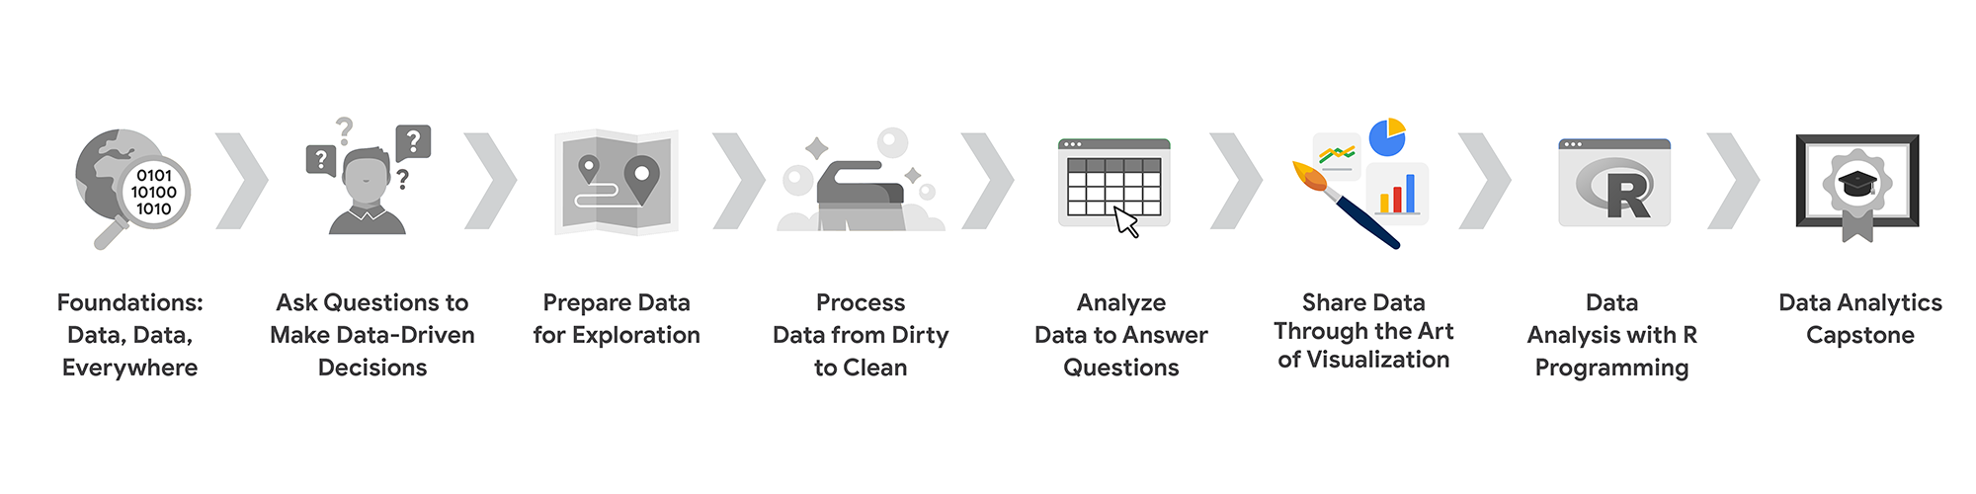

1. [Foundations: Data, Data, Everywhere](https://www.coursera.org/learn/foundations-data/home/welcome)
2. [Ask Questions to Make Data-Driven Decisions](https://www.coursera.org/learn/ask-questions-make-decisions/home/welcome)
3. [Prepare Data for Exploration](https://www.coursera.org/learn/data-preparation/home/welcome)
4. [Process Data from Dirty to Clean](https://www.coursera.org/learn/process-data/home/welcome)
5. [Analyze Data to Answer Questions](https://www.coursera.org/learn/analyze-data/home/welcome)
6. **Share Data Through the Art of Visualization** (this course)
7. [Data Analysis with R Programming](https://coursera.org/learn/data-analysis-r/home/welcome)
8. [Google Data Analytics Capstone: Complete a Case Study](https://coursera.org/learn/google-data-analytics-capstone/home/welcome)

## **Course 6 content**

This course is broken into four modules. Here’s an overview of the skills you’ll gain in each module:

### **Module 1: Visualize data**

In this module, you’ll delve into the various types of data visualizations and explore what makes an effective visualization. You'll also learn about accessibility, design thinking, and other factors that will help you use data visualizations to effectively communicate data insights.

### **Module 2: Create data visualizations with Tableau**

Tableau is a business intelligence and analytics platform that helps people visualize, understand, and make decisions with data. In this part of the course, you’ll become well-versed in Tableau’s dynamic capabilities and learn to inject creativity and clarity into your visualizations, ensuring that your findings are easy to understand.

### **Module 3: Craft data stories**

Connecting your objective with your data through insights is essential to data storytelling. In this part of the course, you’ll get acquainted with the principles of data-driven storytelling and learn to craft compelling narratives using Tableau's dashboard and filtering capabilities, giving life to your data insights.

### **Module 4: Develop presentations and slideshows**

In this part of the course, you’ll discover how to give an effective presentation about your data analysis. This final module teaches you to construct insightful presentations that resonate with your audience. You'll learn to anticipate and address potential questions and to articulate the limitations of your data, ensuring a robust and credible narrative for your stakeholders.

## **What to expect**

Each course offers many types of learning opportunities:

* **Videos** for instructors to teach new concepts and demonstrate the use of tools
* **In-video questions** that pop up from time to time to help you to check your understanding of key concepts and skills
* **Step-by-step guides** you can use to follow along with instructors as they demonstrate tools
* **Readings** to explore topics more in-depth and build on the concepts from the videos
* **Discussion forums** to share, explore, and reinforce lesson topics
* **Discussion prompts** to promote thinking and engagement in the discussion forums
* **Practice quizzes** to prepare you for graded quizzes
* **Graded quizzes** to measure your progress and give you valuable feedback

This program was designed to let you work at your own pace—your personalized deadlines are just a guide. There is no penalty for late assignments. To earn your certificate, you simply need to complete all of the work.

If you miss two assessment deadlines in a row, or if you miss an assessment deadline by two weeks, you'll see a **Reset deadlines** option on the **Grades** page. Click it to switch to a new course schedule with updated deadlines. You can use this option as many times as you need—it won’t remove any progress you’ve already made in the course, but you may find new course content if the instructor updated the course after you started. If you cancel a subscription and then reactivate it, your deadlines will automatically reset.

In this course, you'll be assessed with quizzes that are based on the wide variety of learning materials and activities that reinforce the important skills you’ll develop. Both types of quizzes can be taken more than once.

## **Tips for success**

* It is strongly recommended that you go through the items in each lesson in the order they appear because new information and concepts build on previous knowledge.
* Participate in all learning opportunities to gain as much knowledge and experience as possible.
* If something is confusing, don’t hesitate to replay a video, review a reading, or repeat a self-review activity.
* Use the additional resources that are referenced in this course. They are designed to support your learning. You can find all of these resources in the [**Resources**](https://www.coursera.org/learn/visualize-data/resources/HIQ29)tab.
* When you encounter useful links in this course, bookmark them so you can refer to the information later for study or review.
* Understand and follow the [**Coursera Code of Conduct**](https://www.coursera.support/s/article/208280036-Coursera-Code-of-Conduct?) to ensure that the learning community remains a welcoming, friendly, and supportive place for all members.

**Updates to the course**

As you complete this course, you may notice updates to the content, like new practice materials and additional examples. These updates ensure the program provides up-to-date skills and guidance that will help you in your data analytics career. If you previously completed a graded activity, you *may* need to repeat the assessment in order to complete this course. For more information, check out [the course discussion forum.](https://www.coursera.org/learn/visualize-data/discussions)

### 

UNDERSTAND DATA VISUALIZATION

[WHY DATA VISUALIZATION MATTERS](https://www.coursera.org/learn/visualize-data/lecture/SBc9P/why-data-visualization-matters)

**Your audience should know exactly what they're looking at within the first five seconds of seeing it.** Basically, this means the visual should be clear and easy to follow. In the five seconds after that, your audience should understand the conclusion your visualization is making. Even if they aren't totally familiar with the research you've been doing. They might not agree with your conclusion, and that's okay. You can always use their feedback to adjust your visualization and go back to the data to do further analysis.

So now let's talk about what we have to do to create a visualization that's understandable, effective and, most importantly, convincing. Let's start from the beginning. **Data visualizations are a helpful tool for fitting a lot of information into a small space**.

To do this, **you first need to structure and organize your thoughts**. Think about your objectives and the conclusions you've reached after sorting through data.

**Then think about the patterns you've noticed in the data, the things that surprised you and, of course, how all of this fits together into your analysis**.

Identifying the key elements of your findings help set the stage for how you should organize your presentation.

Check out this data visualization made by David McCandless, a well-known data journalist.

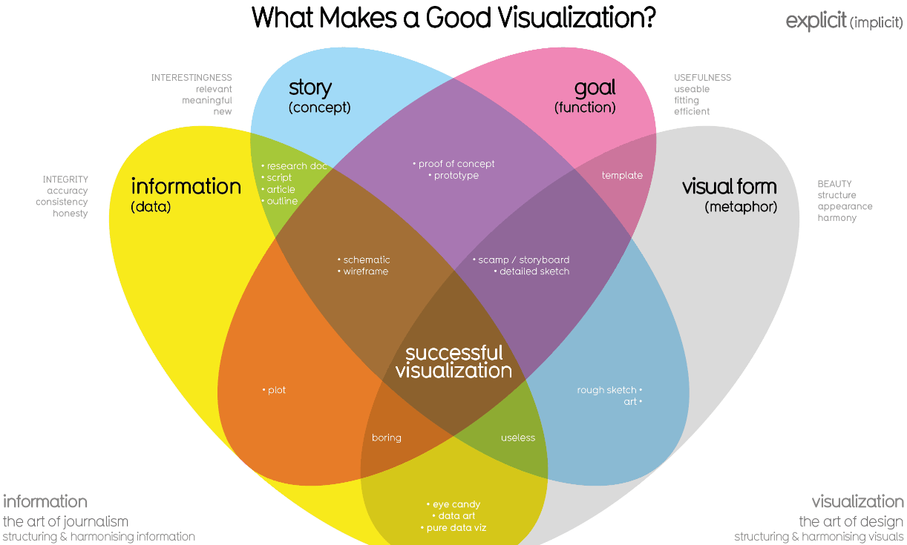

This graphic includes four key elements: **the information or data, the story, the goal and the visual form**. It's arranged in a **four-part Venn diagram**, which tells us that **all four elements are needed for a successful visualization**.

***I - S - G - VF***

So far, you've learned a lot about the **data** used in visualizations. That's important because it's a key building block for your visualization. The story or concept adds meaning to the data and makes it interesting. We'll talk more about the importance of data storytelling later, but for now, just remember that the story and the data combined provide an outline of what you're trying to show. The **goal or function** makes the data both useful and usable, and the visual form creates both beauty and structure. With just two elements, you can create a rough sketch of a visual. This could work if you're at an early stage, but won't give you a complete visualization because you'd be missing other key elements. Even using three elements gets you closer, but you're not quite finished.

For example, if you combine information, goal, and visual form without any story, your visual will probably look fine, but it won't be interesting. **On their own, each element has value, but visualizations only become truly powerful and effective when you combine all four elements in a way that makes sense**. And when you think about all of these elements together, you can create something meaningful for your audience.

At Google I make sure to develop visualizations to tell stories about data that include all four of these elements, and I can tell you that each element is a key to a visualization success. That's why it's so important for you as the analyst to pay close attention to each element as we move forward.

Other people might not know or understand the exact steps you took to come to the conclusions you've made, but that shouldn't stop them from understanding your reasoning. **Basically, an effective data visualization should lead viewers to reach the same conclusion you did, but much more quickly**. Because of the age we live in, we're constantly being shown different ways to view and absorb information. This means that you've already seen lots of visuals you can reference as you design your own visualizations. You have the power to tell convincing stories that could change opinions and shift mindsets. That's pretty cool. But you also have the responsibility to pay attention to the perspectives of others as you create these stories. So it's important to always keep that in mind.

[EFFECTIVE DATA VISUALIZATIONS](https://www.coursera.org/learn/visualize-data/supplement/9xEjx/effective-data-visualizations)

It can be difficult to understand data insights by examining individual data points or a table of information. Often, insights become more obvious when presented in an effective visual format. You can use data visualization (often called “data viz”) techniques to help your audience interpret data in a concise, visual manner.

When creating data visualizations, you must strike a balance between presenting enough information for your audience to understand the meaning of the visualization and not overwhelming them with too much detail. In this reading, you’ll learn tips and techniques for crafting visualizations that are both impactful and effective. You’ll explore:

* Two frameworks for organizing data
* Pre-attentive attributes

## 

## **Frameworks for organizing your thoughts about visualization**

Frameworks help organize your thoughts about data visualization and give you a useful checklist to reference as you plan and evaluate your data visualization. Here are two frameworks that employ slightly different techniques. Both are intended to improve the quality of your visuals.

[The McCandless method](https://www.informationisbeautiful.net/visualizations/what-makes-a-good-data-visualization/)

You learned about the David McCandless method earlier in the course; as a refresher, the McCandless method lists four elements of good data visualization:

1. **Information:** the data with which you’re working
2. **Story:** a clear and compelling narrative or concept
3. **Goal:** a specific objective or function for the visual
4. **Visual form:** an effective use of metaphor or visual expression

The McCandless method provides terminology that isolates the specific elements of a graphic, allowing the person making a visual the ability to evaluate how well those criteria have been met. The aim when crafting a visualization is to incorporate all four elements effectively. Visualizations that fail to incorporate all four elements can be ineffective at communicating insights in various ways. For example, visual form without a goal, story, or data could be a sketch or even art. Data in visual form without a goal or function is just a pretty picture. Data with a goal but no story or visual form can be boring. All four elements need to be present to create an effective visual.

[Kaiser Fung’s Junk Charts trifecta checkup](https://junkcharts.typepad.com/junk_charts/junk-charts-trifecta-checkup-the-definitive-guide.html)

This approach is a set of questions that can help consumers of data visualization critique what they are consuming and determine how effective it is. You can also use these questions to determine if your data visualization is effective:

1. What is the practical question?
2. What does the data say?
3. What does the visual say?

Each of these questions offers an opportunity to investigate a given problem with a slightly different context. A well-designed visual effectively answers all three of those questions at once. Moreover, this framework helps you think about your data viz from the perspective of your audience.

## 

## **Pre-attentive attributes**

In addition to the frameworks mentioned above, several standard building blocks can help you construct your data visualizations.

Creating effective visuals means leveraging what is known about how the brain works, and then using specific visual elements to communicate the information effectively.

**Pre-attentive attributes are the elements of a data visualization that people recognize automatically and without conscious effort.**

**The essential, basic building blocks that make visuals immediately understandable are called marks and channels.**

## 

## 

## **Marks**

**Marks** are basic visual objects such as points, lines, and shapes. Every mark can be broken down into four qualities:

1. **Position:** Where is a specific mark in space relative to a scale or to other marks?

For example, if you’re looking at two different trends, position allows you to compare the pattern of one element relative to another.

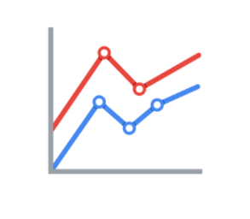

2. **Size:** How big, small, long, or tall is a mark?

The comparison of object sizes can be an easy visual interpretation for humans. This can be very useful for conveying the relationship between categories or data points. However, this also presents a potential problem: The human eye can inadvertently interpret comparisons that aren’t intended to convey meaning. For example, sometimes objects that appear to be the same size when they are not. Controlling the scale of a visual is important even when comparative sizes are not intended to offer information.

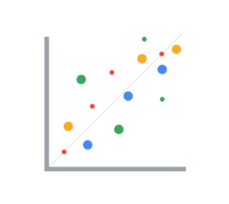

3. **Shape:** Does the shape of a specific object communicate something about it?

Rather than using simple dots or lines, a bit of creativity can enhance how quickly people are able to interpret a visual by using shapes that align with a given application. In the example below, it is immediately obvious that numbers of people are represented because the bars are person-shaped.

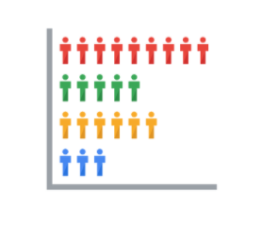

4. **Color:** What color is a mark?

Colors can be used both as a simple differentiator of groupings or as a way to communicate other concepts such as profitable versus unprofitable, or hot versus cold.

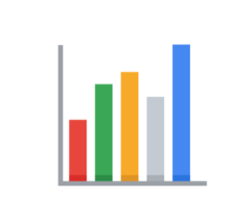

### 

### **Channels**

**Channels** are visual aspects or variables that represent characteristics of the data in a visualization. They are basically specialized marks that have been used to visualize data. It’s important to understand that channels vary in terms of how effective they are at communicating data based on three elements:

1. **Accuracy:** Are the channels helpful in accurately estimating the values being represented?

For example, color is very accurate when communicating categorical differences, such as apples and oranges. But it is much less effective when distinguishing quantitative data, such as 5 from 5.5.

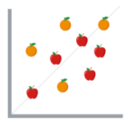

2. **Popout:** How easy is it to distinguish certain values from others?

There are many ways of drawing attention to specific parts of a visual, and lots of them leverage pre-attentive attributes including line length, size, line width, shape, enclosure, hue, and intensity.

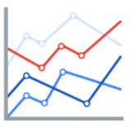

3. **Grouping:** How effective is a channel at communicating groups that exist in the data?

Consider the proximity, similarity, enclosure, connectedness, and continuity of the channel.

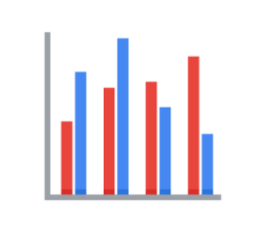

**But, remember: The more you emphasize one single thing, the more that counts**. Emphasis diminishes with each item you emphasize because the items begin to compete with one another.

## **Key takeaways**

Throughout your career as an analyst, you will use different techniques and types of data visualizations to present data and insights in a concise, impactful manner. This will include organizing your data, selecting the right type of data visualizations, and designing them in such a way that they are easy to understand and highly communicative while avoiding any visuals that are misleading or inaccurate.

Keep in mind that data visualization is an art form, and it takes time to develop these skills. Over your career as a data analyst, you will learn how to design and evaluate data visualizations. Use these tips to think critically about data visualization—both as a creator and as an audience member.

## **Resources**

* [The beauty of data visualization](https://www.ted.com/talks/david_mccandless_the_beauty_of_data_visualization?language=en#t-150183): In this video, David McCandless explains the need for design to not just be beautiful, but for it to be meaningful as well. Data visualization must be able to balance function and form for it to be relevant to your audience.
* [‘The McCandless Method’ of data presentation](https://artscience.blog/home/the-mccandless-method-of-data-presentation): At first glance, this blog appears to be written by a David McCandless fan, and it is. However, it contains very useful information and provides an in-depth look at the 5-step process that McCandless uses to present his data.
* [Information is beautiful](https://informationisbeautiful.net/): Founded by McCandless himself, this site serves as a hub of sample visualizations that make use of the McCandless method. Explore data from the news, science, the economy, and so much more and learn how to make visual decisions based on facts from all kinds of sources.
* [Beautiful news](https://informationisbeautiful.net/beautifulnews/): In this McCandless collection, explore uplifting trends and statistics that are beautifully visualized for your creative enjoyment. A new chart is released every day so be sure to visit often to absorb the amazing things happening all over the world.
* [The Wall Street Journal Guide to Information Graphics: The Dos and Don'ts of Presenting Data, Facts, and Figures](https://www.amazon.com/Street-Journal-Guide-Information-Graphics/dp/0393072959): This is a comprehensive guide to data visualization, including chapters on basic data visualization principles and how to create useful data visualizations even when you find yourself in a tricky situation. This is a useful book to add to your data visualization library, and you can reference it over and over again.

[CONNECT IMAGES WITH DATA](https://www.coursera.org/learn/visualize-data/lecture/h7P9i/connect-images-with-data)

Earlier we talked about why data visualizations are so important to both analysts and stakeholders.

Now we'll discuss the connections you can make between data and images in your visualizations. **Visual communication of data is important to those using the data to help make decisions.**

To better understand the connection between data and images, let's talk about some examples of data visualizations and how they can communicate data effectively. You may come across lots of these in your daily life. We'll explore them a little bit more here.

A good place to start is a bar graph. **Bar graphs use size contrast to compare two or more values.**

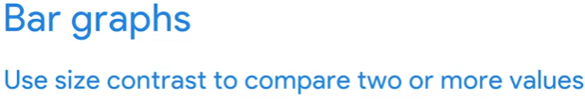

The horizontal line of a bar graph usually placed at the bottom, is called the x-axis, and bar graphs with vertical bars, **the x-axis, are used to represent categories, time periods, or other variables.**

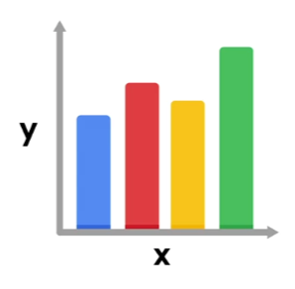

The vertical line of a bar graph usually placed to the left is called the y-axis. **The y-axis usually has a scale of values for the variables.**

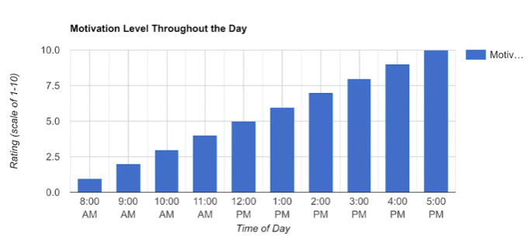

In this example, the time of day is compared to someone's level of motivation throughout the whole workday. **Bar graphs are a great way to clarify trends**.

Here, it's clear this person's motivation is low at the beginning of the day and gets higher and higher by the end of the workday. This type of visualization makes it very easy to identify patterns.

Another example is a **line graph**. **Line graphs are a type of visualization that can help your audience understand shifts or changes in your data.**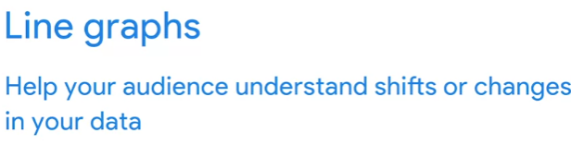

They're usually used to track changes through a period of time, but they can be paired with other factors too.

In this line graph, we're using two lines to compare the popularity of cats and dogs over a period of time.

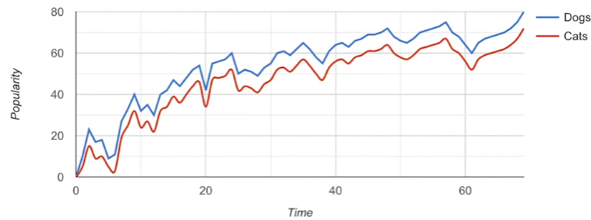

With two different line colors, we can immediately tell that dogs are more popular than cats. We'll talk more about using colors and patterns to make visualizations more accessible to audiences later too. Even as a line moves up and down, there's a general trend upwards and the line for dogs always stays higher than the line for cats.

Now let's check out another visualization you'll probably recognize. Say hello to the **pie chart**. **Pie charts show how much each part of something makes up the whole.** 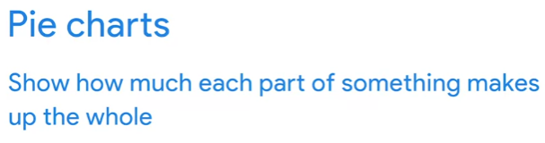

This pie chart shows us all the activities that make up someone's day.

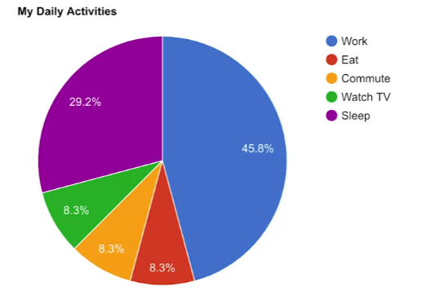

Half of it's spent working, which is shown by the amount of space that the blue section takes up. From a quick scan, you can easily tell which activities make up a good chunk of the day in this pie chart and which ones take up less time.

Earlier, we learned how maps help organize data geographically.

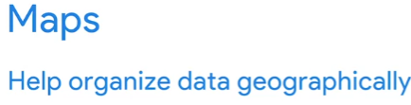

The great thing about maps is they can hold a lot of location-based information and they're easy for your audience to interpret.

This example shows survey data about people's happiness in Europe.

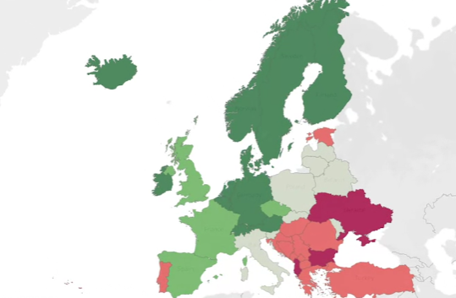

The borderlines are well-defined and the colors added make it even easier to tell the countries apart. Understanding the data represented here, which we'll come back to again later, can happen pretty quickly.

So data visualization is an excellent tool for making the connection between an image and the information it represents, but **it can sometimes be misleading**.

**One way visualizations can be manipulated is with scaling and proportions**. Think of a pie chart. Pie charts show proportions and percentages between categories. Each part of the circle or pi should reflect its percentage to the whole, which is equal to 100 percent. So if you want to visualize your sales analysis to show the percentage of your company sales that come from online transactions, you could use a pie chart. The size of each slice would be the percentage of total sales that it represents. So if your online sales accounted for 60 percent, the slice would be 60 percent of the whole pie.

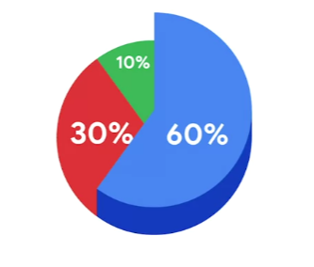

**Now here's a misleading pie chart.**

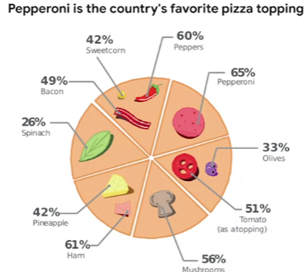

It's supposed to show opinions about pizza toppings, but each slice or segment represents more than one option. They all add up to well over 100 percent. There are lots of ingredients listed below the image that are not even included in the visual data. All of the segments are the same size, even though they're supposed to be showing different values. **If a visualization looks confusing then it probably is confusing**.

Let's explore another example where the size of the graphic components comes into play.

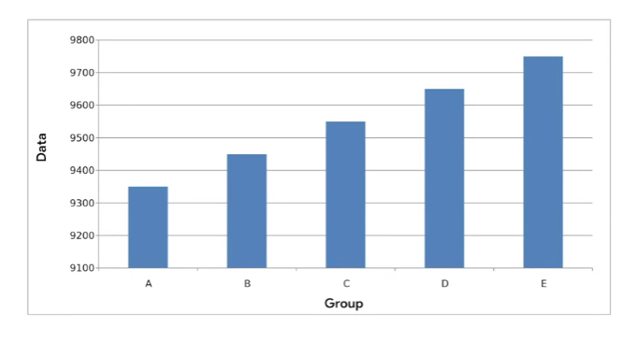

This time with a bar chart. In a truncated bar chart like this one, the values on the y-axis don't start at zero. The data points start at 9,100 and at intervals of 100.

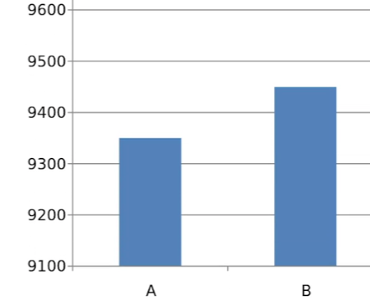

This makes it seem like the data, let's say, it's for novel clicks per day on different website links, is fairly wide-ranging. In this view, website E seems to clearly receive way more clicks than website D, which receives more clicks than website C and so on. While the graph is clear and the elements are easy to understand, the way the data is presented is misleading.

Let's try to fix this by changing the graph's y-axis, so that it starts at zero instead.

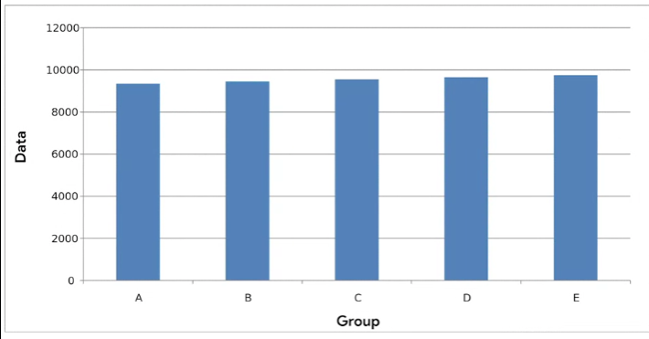

Now, the difference between the website clicks per day doesn't look nearly as drastic.

By making the y-axis start at zero, we're changing the visual proportions to be more accurate and more honest.

**Some platforms always start their y-axis at zero, but other programs like spreadsheets might not fix the y-axis. So it's important to keep this in mind when creating visualizations**. By following the conventions of data analysis, you'll be able to avoid misleading visualizations. You always want your visualization to be clear and easy to understand, but never at the expense of communicating ideas that are true to the data. So we've talked about some effective data-driven visualizations like bar graphs, line graphs, and pie charts, and when to use them. On top of that, we've discussed some things to avoid in your visualizations to keep them from being misleading. Coming up, we'll check out how to make those visualizations reach your target audience. See you then.

[THE BEAUTY OF VISUALIZING](https://www.coursera.org/learn/visualize-data/supplement/YHHg5/the-beauty-of-visualizing)

You will find that organizing your data and communicating your results are significant parts of a data analyst’s role. In this reading, you are going to navigate different resources for effective data visualization that will allow you to choose the best model to present your data.

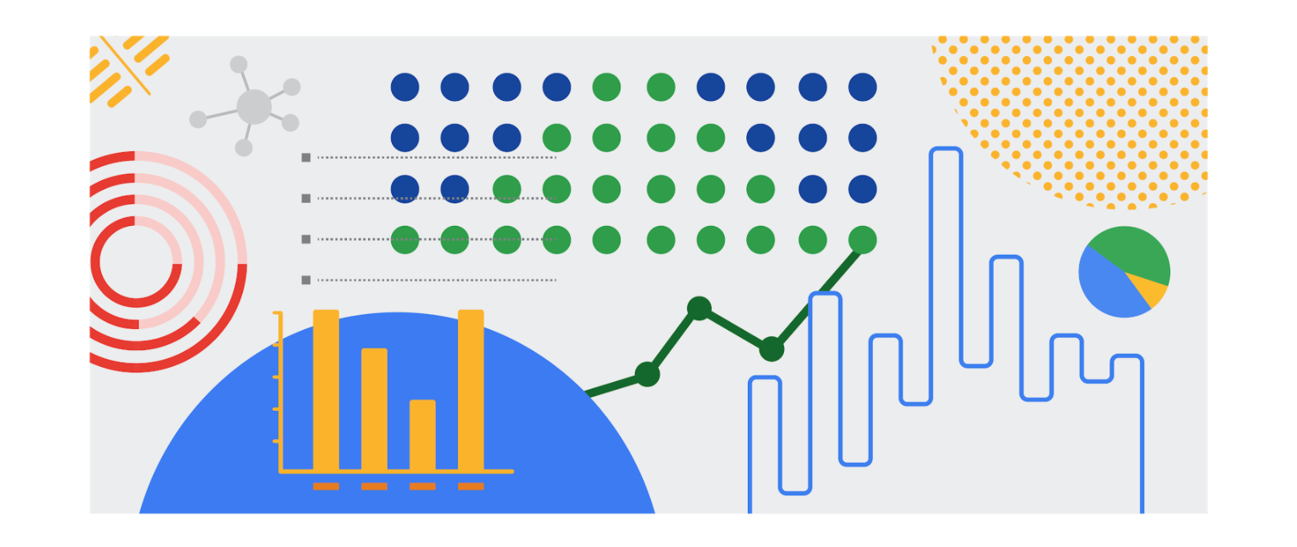

## **Inspiration is in the air**

**Data visualization** is the graphical representation of data. But why should data analysts care about data visualization? Well your audience won’t always have the ability to interpret or understand the complex information that you relay to them so your job is to inform them of your analysis in a way that is meaningful, engaging, and easy to understand. Part of why data visualization is so effective is because people’s eyes are drawn to colors, shapes, and patterns, which makes those visual elements perfect for telling a story that goes beyond just the numbers.

Of course, one of the best ways to understand the importance of data visualization is to go through different examples of it. As a junior data analyst, you want to have several visualization options for your creative process whenever you need. Below is a list of resources that can inspire your next data-driven decisions, as well as teach you how to make your data more accessible to your audience:

* [The data visualization catalogue](https://datavizcatalogue.com/#google_vignette): Not sure where to start with data visualization? This catalogue features a range of different diagrams, charts, and graphs to help you find the best fit for your project. As you navigate each category, you will get a detailed description of each visualization as well as its function and a list of similar visuals.
* [The 25 best data visualizations](https://visme.co/blog/best-data-visualizations/): In this collection of images, explore the best examples of data that gets made into a stunning visual. Simply click on the link below each image to get an in-depth view of each project, and learn why making data visually appealing is so important.
* [10 data visualization blogs](https://www.tableau.com/learn/articles/best-data-visualization-blogs): Each link will lead you to a blog that is a fountain of information on everything from data storytelling to graphic data. Get your next great idea or just browse through some visual inspiration.
* [Information is beautiful](https://informationisbeautiful.net/wdvp/gallery-2019/): Founded by David McCandless, this gallery is dedicated to helping you make clearer, more informed visual decisions based on facts and data. These projects are made by students, designers, and even data analysts to help you gain insight into how they have taken their own data and turned it into visual storytelling.
* [Data studio gallery](https://datastudio.google.com/gallery?category=visualization): Information is vital, but information presented in a digestible way is even more useful. Browse through this interactive gallery and find examples of different types of data communicated visually. You can even use the data studio tool to create your own data-driven visual.

## **Engage your audience**

Remember: an important component of being a data analyst is the ability to communicate your findings in a way that will appeal to your audience. Data visualization has the ability to make complex (and even monotonous) information easily understood, and knowing how to utilize data visualization is a valuable skill to have. Your goal is always to help the audience have a conversation with the data so your visuals draw them into the conversation. This is especially true when you have to help your audience engage with a large amount of data, such as the flow of goods from one country to other parts of the world.

[A RECIPE FOR A POWERFUL VISUALIZATION](https://www.coursera.org/learn/visualize-data/lecture/OIKNa/a-recipe-for-a-powerful-visualization)

You're back and ready to learn how to create powerful data visualizations.

Coming up, we'll explore how to take our findings and turn them into compelling visuals.

Earlier, we discussed the relationship between data and images. **Now we'll build on that to explore what visualizations can reveal to your audience and how to make your graphics as effective as possible.**

**One of your biggest considerations when creating a data visualization is where you'd like your audience to focus**. Showing too much can be distracting and leave your audience confused. **In some cases, restricting data can be a good thing**. On the other hand, showing too little can make your visualization unclear and less meaningful. As a general rule, as long as it's not misleading, you should visually represent only the data that your audience needs in order to understand your findings.

Now let's talk about what you can show with visualizations.

**Change over time is a big one**. If your analysis involves how the data has changed over a certain period, which could be days, weeks, months, or years. You can set your visualization to show only the time period relevant to your objective. This visualization shows the search interests in news story topics like environment and science and social issues.

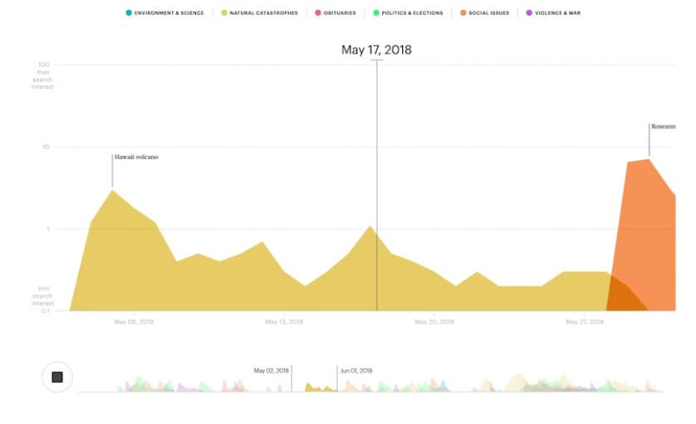

The viz is set up to show how the search entries change day to day. The bubbles represent the most popular topic on each day in a given part of the US. As new stories come up, the data changes to reflect the topic of those stories. If we wanted the data for weekly or monthly news cycles, we change the interactive feature to show changes by week or month.

Another situation is **when you need to show how your data is distributed**. A histogram resembles a bar graph, but it's a chart that shows how often data values fall into certain ranges.

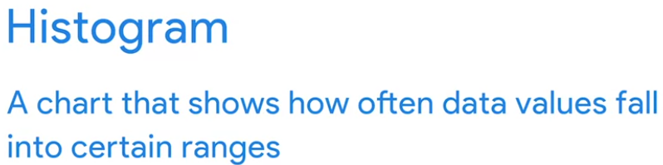

This histogram shows a lot of data and how it's distributed on a narrow range from a negative one to a positive one.

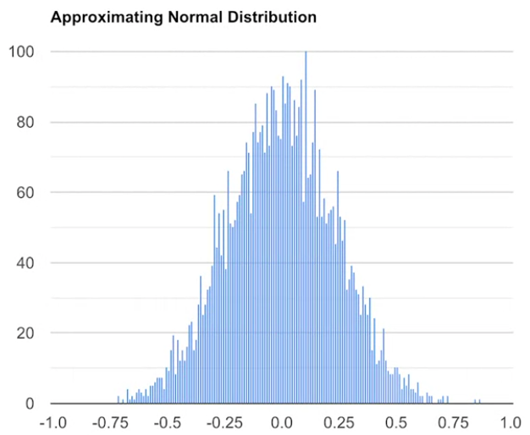

Each bin or bucket, as the bar is called, contains a certain number of values that fall into one small part of the range.

**If you don't need to show that much data, other histograms would be more effective**, like this one about the length of dinosaurs.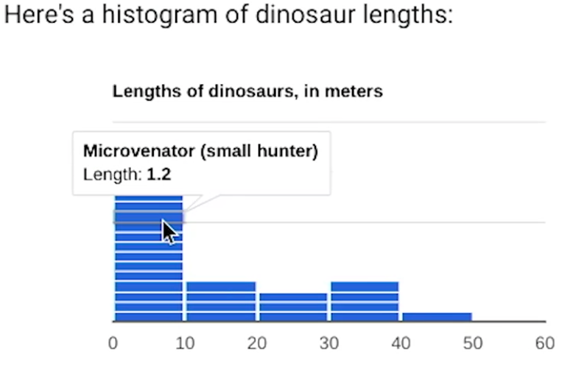

Here the bins or buckets of data values are segmented. You can show each value that falls into each part of the range. If your data needs to be ranked, like when ordering the number of responses to survey questions. You should first think about what you want to highlight in your visualization.

**Bar charts with horizontal bars effectively show data that are ranked, with bars arranged in ascending or descending order**. A bar chart should always be ranked by value, unless there's a natural order to the data like age or time, for example.

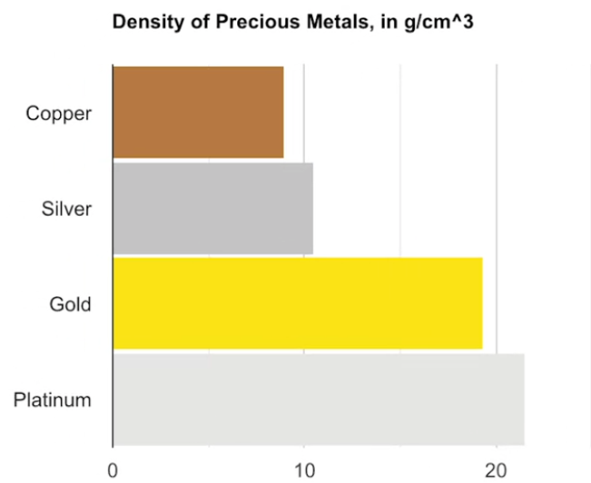

This simple bar chart shows metals like gold and platinum ranked by density. An audience would be able to clearly see the ranking and quickly determine which metals had the highest density, even if this database included a lot more metals.

**Correlation charts can show relationships among data**, but they should be used with caution because they might lead viewers to think that the data shows causation. **Causation or a cause-effect relationship occurs when an action directly leads to an outcome.** 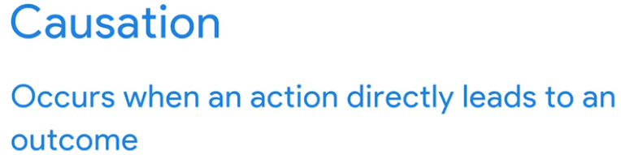

**Correlation and causation are often mixed up because humans like to find patterns even when they don't exist**.

If two variables look like they're associated in some way, we might assume that one is dependent on the other. That implies causation, even if the variables are completely independent.

If we put that data into a visualization, then it would be misleading. **But correlation charts that do show causation can be effective**.

For example, this correlation chart has one line of data showing the average traffic for Google searches on Tuesdays in Brazil.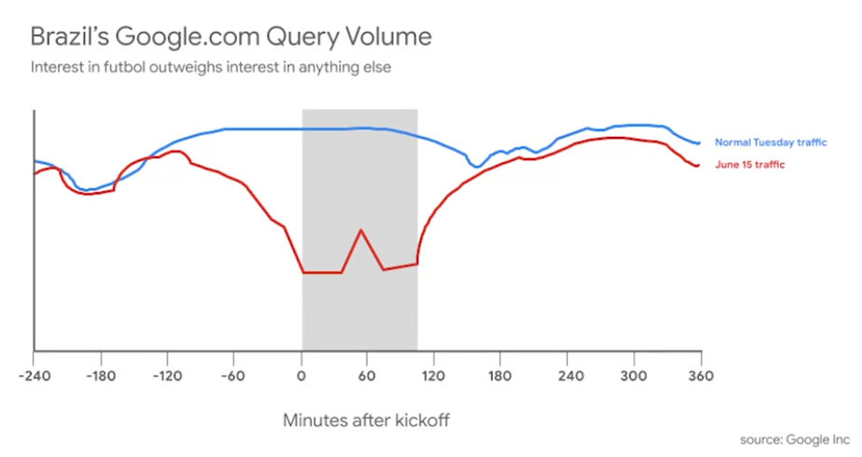

The other lines for a specific date of search traffic, June 15th. The data is automatically correlated because both lines are representing the same basic information. But the chart also shows one big difference. When a football match or soccer match for Americans began on June 15th, the search traffic showed a significant drop. This implies causation. Football is a very popular and important sport for Brazilians, and the data in this chart verifies that.

We've now talked about **time series charts, histograms, ranked bar charts, and correlation charts**. 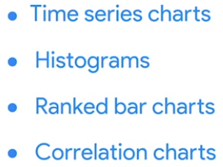

Each of these charts can visualize a different type of analysis. Your business objective and audience will help figure out which of these common visualizations to choose. Or you may want to check some other kinds of visualizations out there. There are also glossary visualizations that you'll be able to reference later. That wraps up our lesson on creating visualizations. Coming up next, we'll add some more layers to your planning and execution of visuals. Hang on tight.

[CORRELATION AND CAUSATION](https://www.coursera.org/learn/visualize-data/supplement/PPdt5/correlation-and-causation)

In this reading, you will examine correlation and causation in more detail. Let’s review the definitions of these terms:

* **Correlation** in statistics is the measure of the degree to which two variables move in relationship to each other. An example of correlation is the idea that “As the temperature goes up, ice cream sales also go up.” It is important to remember that correlation doesn’t mean that one event causes another. But, it does indicate that they have a pattern with or a relationship to each other. If one variable goes up and the other variable also goes up, it is a positive correlation. If one variable goes up and the other variable goes down, it is a negative or inverse correlation. If one variable goes up and the other variable stays about the same, there is no correlation.
* **Causation** refers to the idea that an event leads to a specific outcome. For example, when lightning strikes, we hear the thunder (sound wave) caused by the air heating and cooling from the lightning strike. Lightning causes thunder.

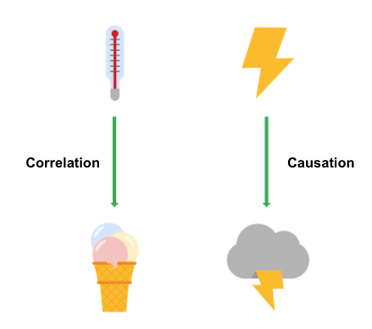

## **Why is differentiating between correlation and causation important?**

When you make conclusions from data analysis, you need to make sure that you don’t assume a causal relationship between elements of your data when there is only a correlation. When your data shows that outdoor temperature and ice cream consumption both go up at the same time, it might be tempting to conclude that hot weather **causes** people to eat ice cream. But, a closer examination of the data would reveal that every change in temperature doesn’t lead to a change in ice cream purchases. In addition, there might have been a sale on ice cream at the same time that the data was collected, which might not have been considered in your analysis.

Knowing the difference between correlation and causation is important when you make conclusions from your data since the stakes could be high. The next two examples illustrate the high stakes to health and human services.

### **Cause of disease**

For example, pellagra is a disease with symptoms of dizziness, sores, vomiting, and diarrhea. In the early 1900s, people thought that the disease was caused by unsanitary living conditions. Most people who got pellagra also lived in unsanitary environments. But, a closer examination of the data showed that pellagra was the result of a lack of niacin (Vitamin B3). Unsanitary conditions were related to pellagra because most people who couldn’t afford to purchase niacin-rich foods also couldn’t afford to live in more sanitary conditions. But, dirty living conditions turned out to be a correlation only.

**Distribution of aid**

Here is another example. Suppose you are working for a government agency that provides SNAP benefits. You noticed from the agency’s Google Analytics that people who qualify for the benefits are browsing the official website, but they are leaving the site without signing up for benefits. You think that the people visiting the site are leaving because they aren’t finding the information they need to sign up for SNAP benefits. Google Analytics can help you find clues (correlations), like the same people coming back many times or how quickly people leave the page. One of those correlations might lead you to the actual cause, but you will need to collect additional data, like in a survey, to know exactly why people coming to the site aren’t signing up for SNAP benefits. Only then can you figure out how to increase the sign-up rate.

**Key takeaways**

In your data analysis, remember to:

* Critically analyze any correlations that you find
* Examine the data’s context to determine if a causation makes sense (and can be supported by all of the data)
* Understand the limitations of the tools that you use for analysis

**Further information**

You can explore the following article and training for more information about correlation and causation:

* [**Correlation is not causation**](https://towardsdatascience.com/correlation-is-not-causation-ae05d03c1f53)**:** This article describes the impact to a business when correlation and causation are confused.
* [**Correlation and causation**](https://www.khanacademy.org/test-prep/praxis-math/praxis-math-lessons/gtp--praxis-math--lessons--statistics-and-probability/a/gtp--praxis-math--article--correlation-and-causation--lesson) **(Khan Academy lesson):** This lesson describes correlation and causation along with a working example. Follow the examples of the analysis and notice if there is a positive correlation between frostbite and sledding accidents.

[DYNAMIC VISUALIZATIONS](https://www.coursera.org/learn/visualize-data/lecture/423YL/dynamic-visualizations)

So far we've shown that there's lots of choices you'll make as a data analyst when creating visualizations. Each of your choices should help make sure that your visuals are meaningful and effective.

**Another choice you'll need to make is whether you want your visualizations to be static or dynamic**. Static visualizations do not change over time unless they're edited. 

They can be useful when you want to control your data and your data story. Any visualization printed on paper is automatically static.

Charts and graphs created in spreadsheets are often static too.

For example, the owner of this spreadsheet might have to change the data in order for the visualization to update.

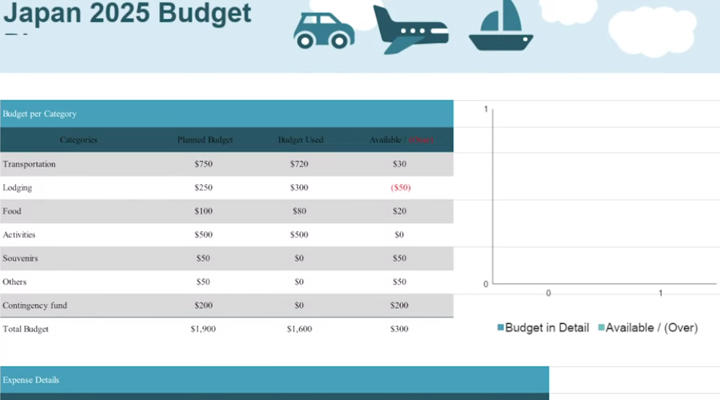

Now, **dynamic visualizations are interactive or change over time**. The interactive nature of these graphics means that users have some control over what they see. 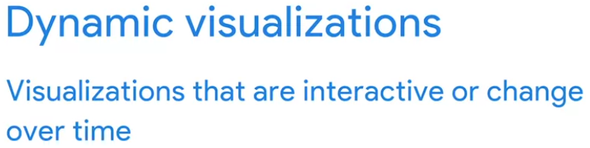

This can be helpful if stakeholders want to adjust what they're able to view.

Let's check out a visualization about happiness that we've created in Tableau. Tableau is a business intelligence and analytics platform that helps people see, understand, and make decisions with data. Visualizations in Tableau are automatically interactive.

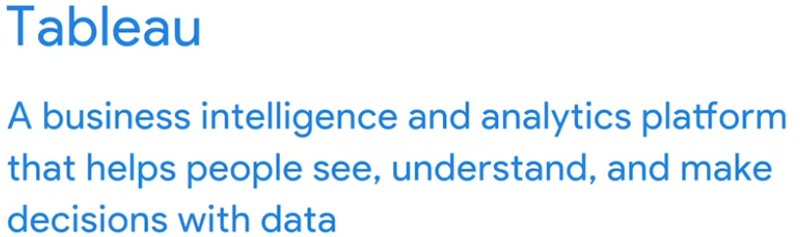

We'll go into the dashboard to see how the happiness score has changed from 2015 to 2017. We can check this out in our 12th slide, yearly happiness changes.

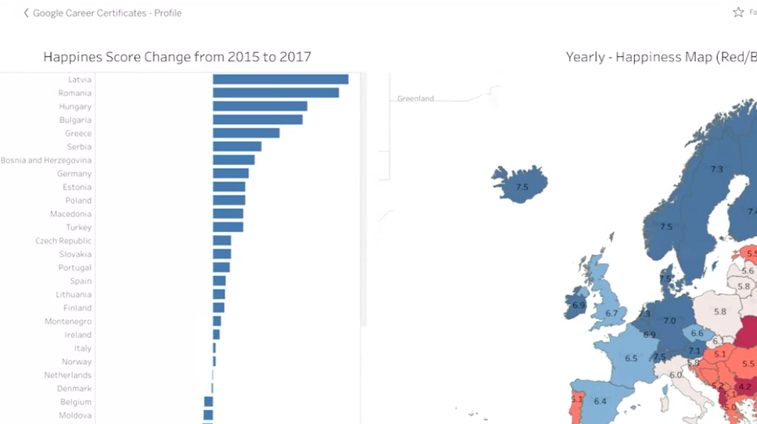

On the left are the country level changes in happiness score. The countries are sorted by largest increase to largest decrease. On the right, there's a map with overall happiness scores. The color scale moves from blue for the countries with the highest happiness score, to red for those with the lowest. If you look below the map, you'll notice a year to view_slider where people can choose which year's happiness scores to display on the map.

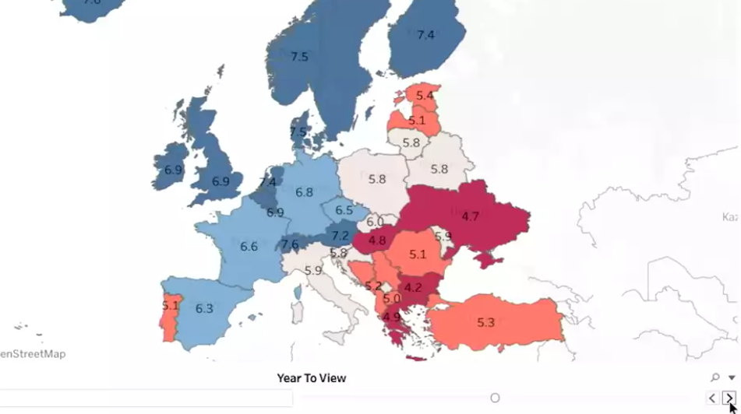

It's currently set for 2016, but if someone wants to know the scores for 2015 or 2017, they can adjust the slider. They could then make note of how the color-coding and score labels change from year to year. Other dynamic visualizations upload new data automatically. These bar graphs continually update data by the minute and second. Other data visuals can do the same by day, week or month. If you need to, you can show trends in real-time. Having an interactive visualization can be useful for both you and the audience you share it with.

**But it's good to remember that the more power you give the user, the less control you have over the story you want the data to tell.** It's something to keep in mind as you learn how to create your own visualizations. **You want to find the right balance between interactivity and control.**

**Something else to consider is, a choice between using a static or dynamic visualization.** This will usually depend on the data you're visualizing, the audience you're presenting to, and how you're giving your presentation. Now that we've made some decisions about **what kind of data vis we want to create**, **we can start thinking about the design**, which is exactly where we're going to start talking about next time. See you there.

[THE WONDERFUL WORLD OF VISUALIZATIONS](https://www.coursera.org/learn/visualize-data/supplement/j9Wdl/the-wonderful-world-of-visualizations)

As a data analyst, you will often be tasked with relaying information and data that your audience might not readily understand. **Presenting your data visually is an effective way to communicate complex information and engage your stakeholders**. One question to ask yourself is: “**what is the best way to tell the story within my data?**” This reading includes several options for you to choose from (although there are many more).

## **Line chart**

A **line chart** is used to track changes over short and long periods of time. When smaller changes exist, line charts are better to use than bar graphs. Line charts can also be used to compare changes over the same period of time for more than one group.

Let’s say you want to present the graduation frequency for a particular high school between the years 2008-2012. You would input your data in a table like this:

| **Year** | **Graduation rate** |
| --- | --- |
| 2008 | 87 |
| 2009 | 89 |
| 2010 | 92 |
| 2011 | 92 |
| 2012 | 96 |

From this table, you are able to present your data in a line chart like this:

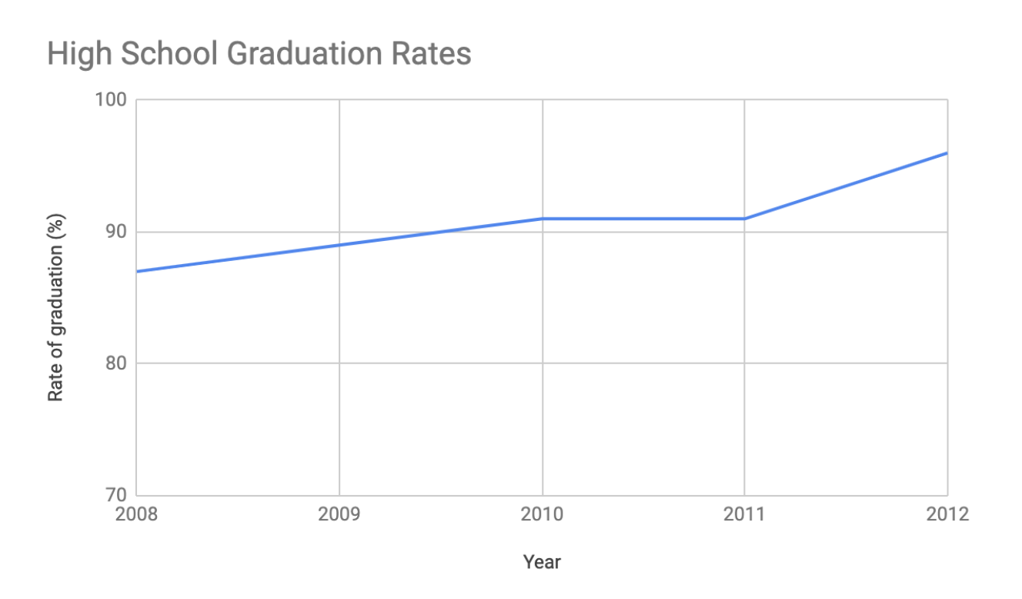

Maybe your data is more specific than above. For example, let’s say you are tasked with presenting the difference of graduation rates between male and female students.

Then your chart would resemble something like this:

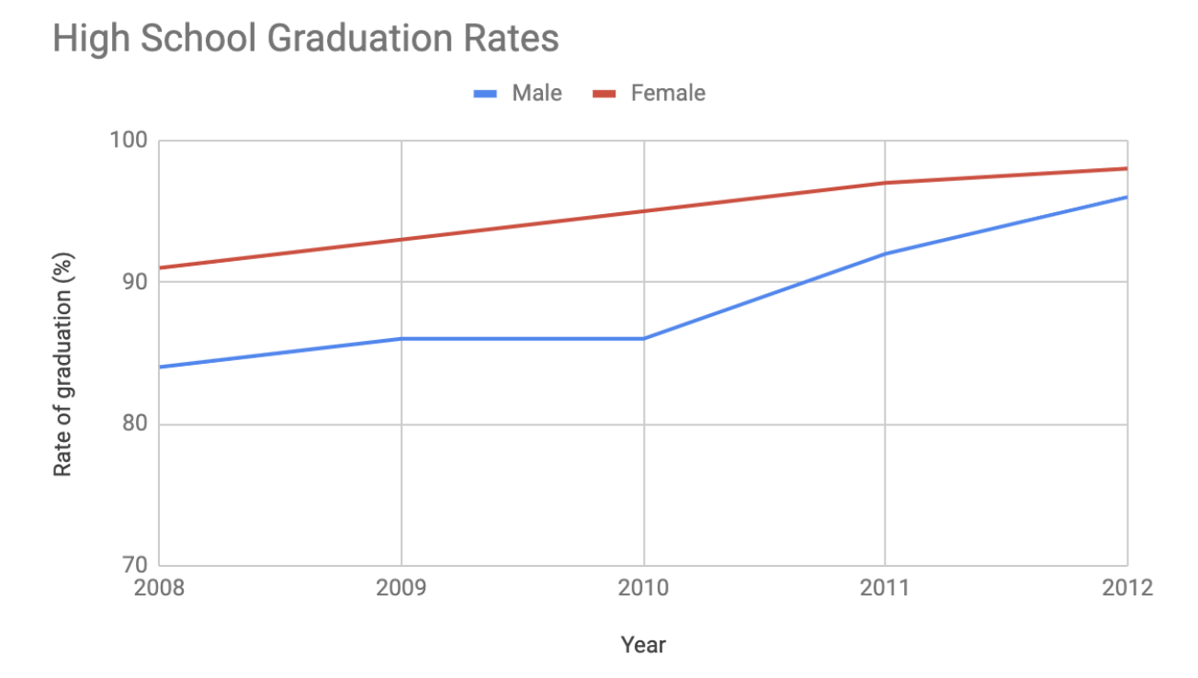

## **Column chart**

**Column charts** use size to contrast and compare two or more values, using height or lengths to represent the specific values.

The below is example data concerning sales of vehicles over the course of 5 months:

| **Month** | **Vehicles sold** |
| --- | --- |
| August | 2,800 |
| September | 3,700 |
| October | 3,750 |
| November | 4,300 |
| December | 4,600 |

Visually, it would resemble something like this:

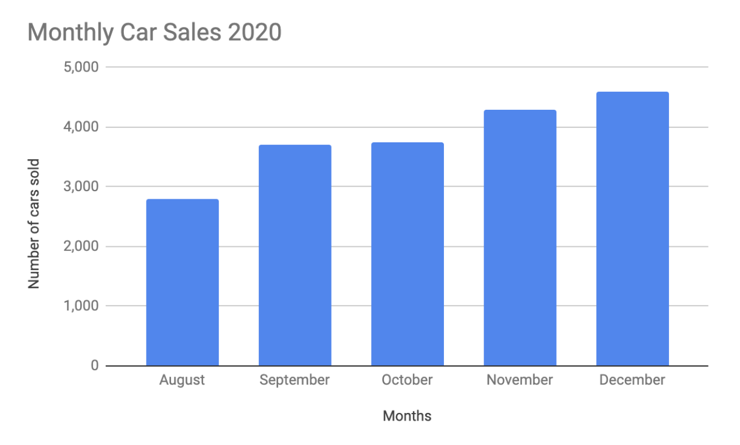

What would this column chart entail if we wanted to add the sales data for a competing car brand?

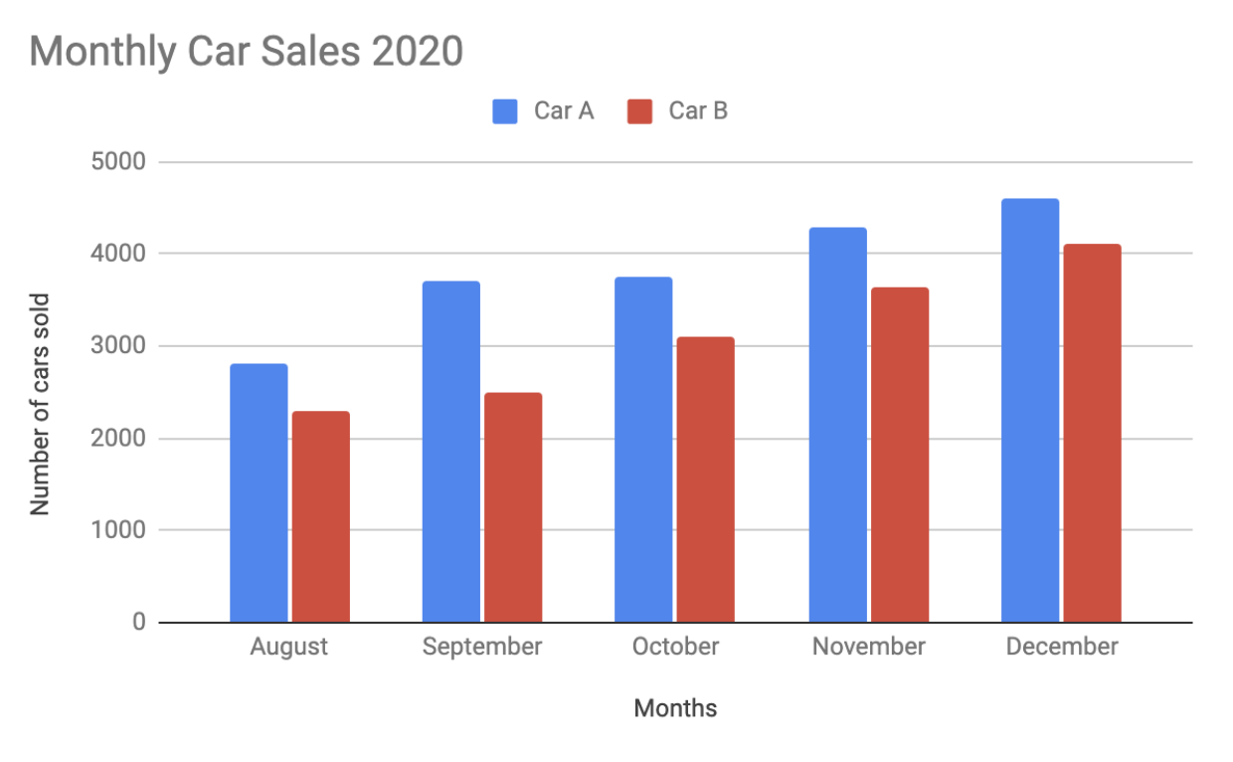

## **Heatmap**

Similar to bar charts, **heatmaps** also use color to compare categories in a data set. They are mainly used to show relationships between two variables and use a system of color-coding to represent different values. The following heatmap plots temperature changes for each city during the hottest and coldest months of the year.

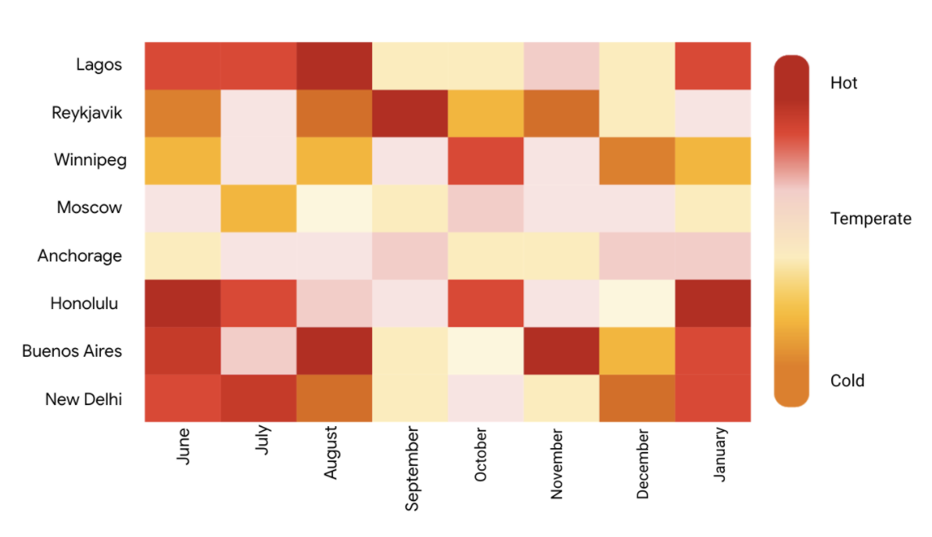

## 

## **Pie chart**

The **pie chart** is a circular graph that is divided into segments representing proportions corresponding to the quantity it represents, especially when dealing with parts of a whole.

For example, let’s say you are determining favorite movie categories among avid movie watchers. You have gathered the following data:

| **Movie category** | **Preference** |
| --- | --- |
| Comedy | 41% |
| Drama | 11% |
| Sci-fi | 3% |
| Romance | 17% |
| Action | 28% |

Visually, it would resemble something like this:

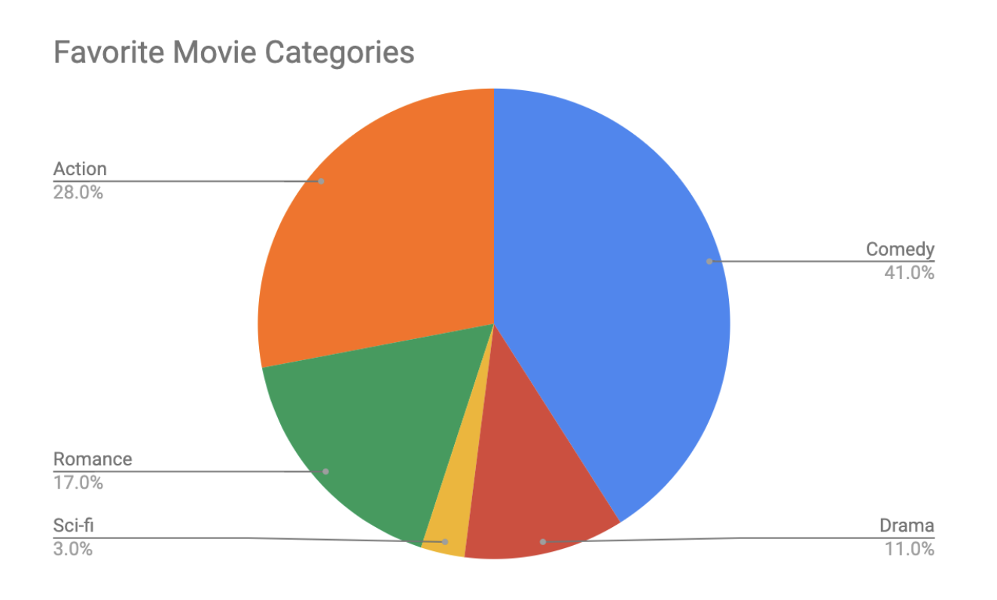

## 

## **Scatterplot**

**Scatterplots** show relationships between different variables. Scatterplots are typically used for two variables for a set of data, although additional variables can be displayed.

For example, you might want to show data of the relationship between temperature changes and ice cream sales. It would resemble something like this:

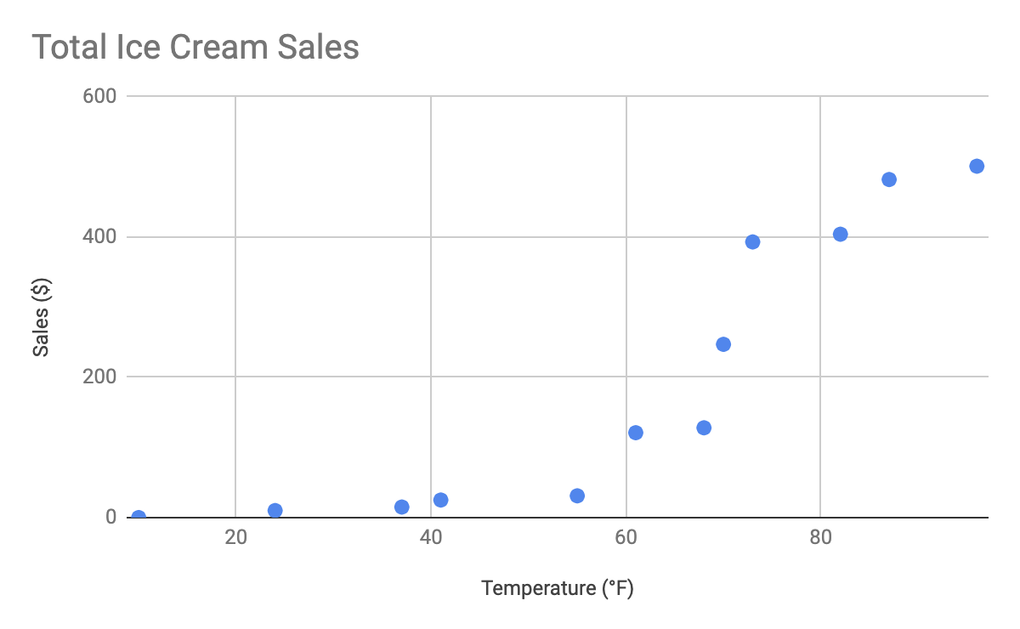

As you may notice, the higher the temperature got, the more demand there was for ice cream—so the scatterplot is great for showing the relationship between the two variables.

## **Distribution graph**

A **distribution graph** displays the spread of various outcomes in a dataset.

Let’s apply this to real data. To account for its supplies, a brand new coffee shop owner wants to measure how many cups of coffee their customers consume, and they want to know if that information is dependent on the days and times of the week. That distribution graph would resemble something like this:

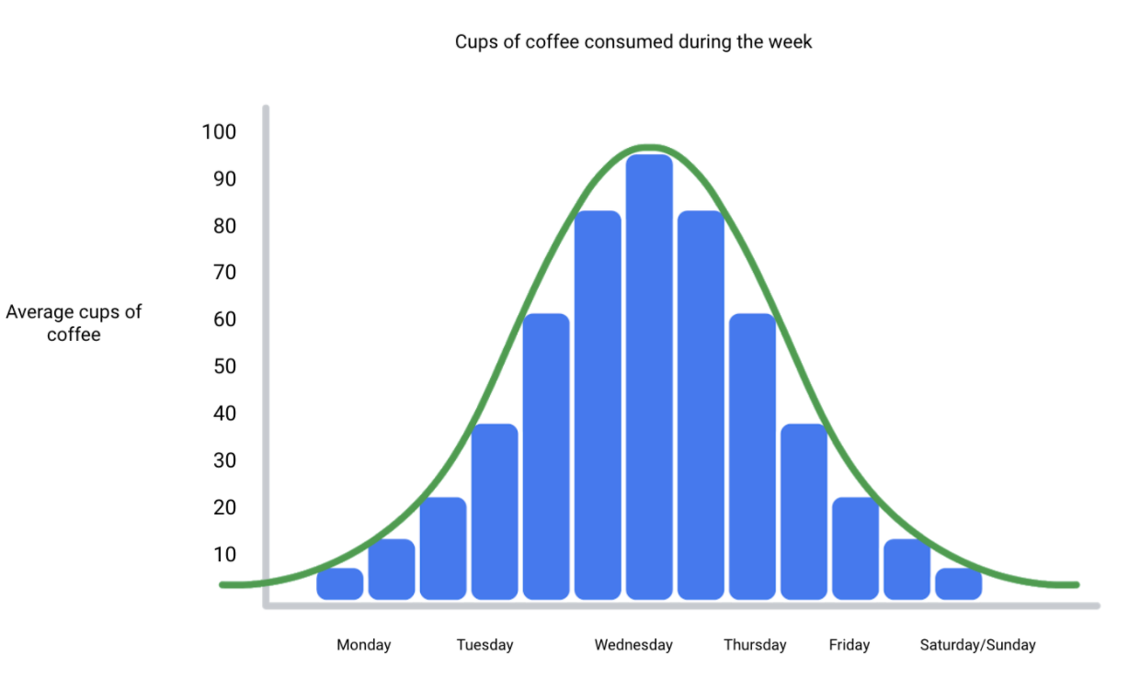

From this distribution graph, you may notice that the amount of coffee sales steadily increases from the beginning of the week, reaching the highest point mid-week, and then decreases towards the end of the week.

If outcomes are categorized on the x-axis by distinct numeric values (or ranges of numeric values), the distribution becomes a **histogram**.

If data is collected from a customer rewards program, they could categorize how many customers consume between one and ten cups of coffee per week. The histogram would have ten columns representing the number of cups, and the height of the columns would indicate the number of customers drinking that many cups of coffee per week.

Reviewing each of these visual examples, where do you notice that they fit in relation to your type of data?

**One way to answer this is by evaluating patterns in data.**

**Meaningful patterns can take many forms, such as**:

* **Change:** This is a trend or instance of observations that become different over time. A great way to measure change in data is through a line or column chart.
* **Clustering:** A collection of data points with similar or different values. This is best represented through a distribution graph.
* **Relativity:** These are observations considered in relation or in proportion to something else. You have probably seen examples of relativity data in a pie chart.
* **Ranking:** This is a position in a scale of achievement or status. Data that requires ranking is best represented by a column chart.
* **Correlation:** This shows a mutual relationship or connection between two or more things. A scatterplot is an excellent way to represent this type of data pattern.

## **Studying your data**

Data analysts are tasked with collecting and interpreting data as well as displaying data in a meaningful and digestible way. Determining how to visualize your data will require studying your data’s patterns and converting it using visual cues. Feel free to practice your own charts and data in spreadsheets. Simply input your data in the spreadsheet, highlight it, then insert any chart type and view how your data can be visualized based on what you choose.

[DATA GROWS ON DECISION TREES](https://www.coursera.org/learn/visualize-data/supplement/XvN2U/data-grows-on-decision-trees)

With so many visualization options out there for you to choose from, how do you decide what is the best way to represent your data?

A **decision tree** is a decision-making tool that allows you, the data analyst, to make decisions based on key questions that you can ask yourself. Each question in the visualization decision tree will help you make a decision about critical features for your visualization.

Below is an example of a basic decision tree to guide you towards making a data-driven decision about which visualization is the best way to tell your story. Please note that there are many different types of decision trees that vary in complexity, and can provide more in-depth decisions.

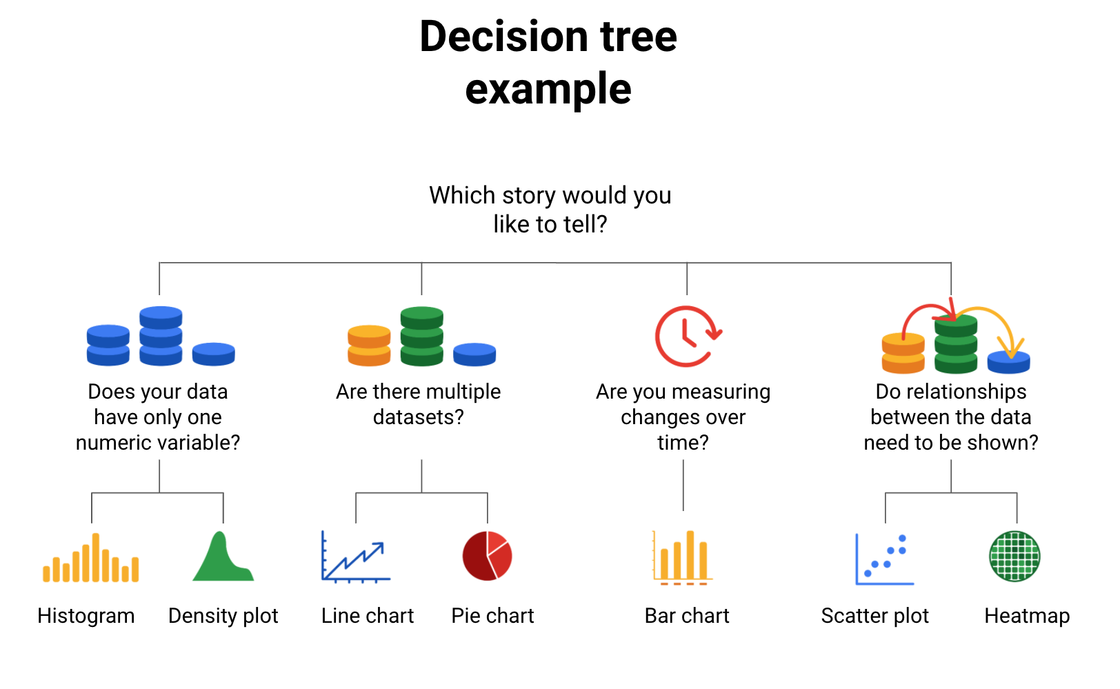

## 

## **Begin with your story**

Start off by evaluating the type of data you have and go through a series of questions to determine the best visual source:

* **Does your data have only one numeric variable?** If you have data that has one, continuous, numerical variable, then a histogram or density plot are the best methods of plotting your categorical data. Depending on your type of data, a bar chart can even be appropriate in this case. For example, if you have data pertaining to the height of a group of students, you will want to use a histogram to visualize how many students there are in each height range:

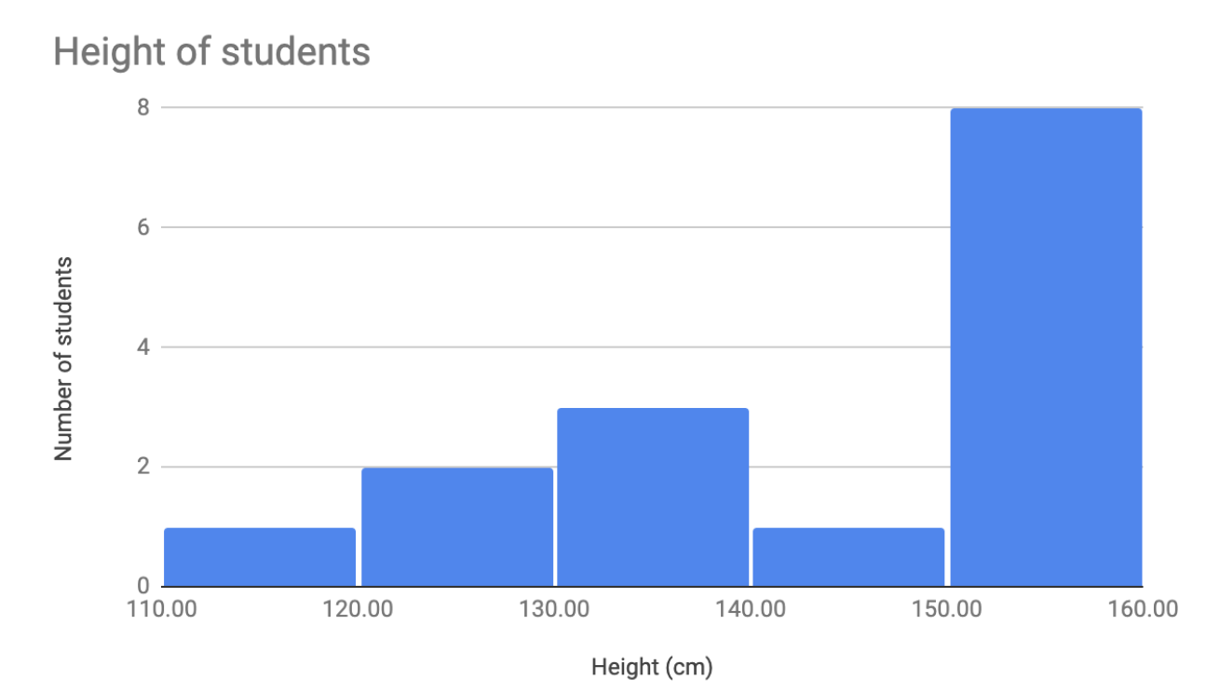

* **Are there multiple datasets?** For cases dealing with more than one set of data, consider a line or pie chart for accurate representation of your data. When you are measuring quarterly sales figures of your company. Below are examples of this data plotted on both a line and pie chart.

A line chart will connect multiple data sets over a single, continuous line, showing how numbers have changed over time.

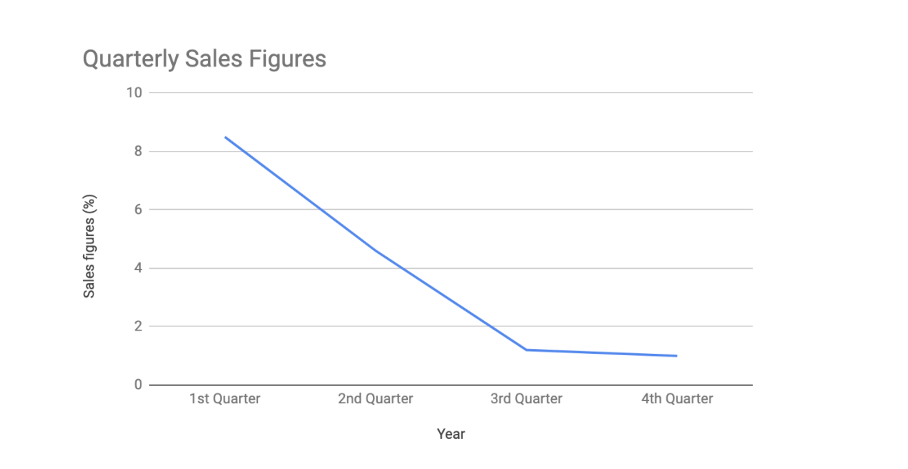

A pie chart is good for dividing a whole into multiple categories or parts.

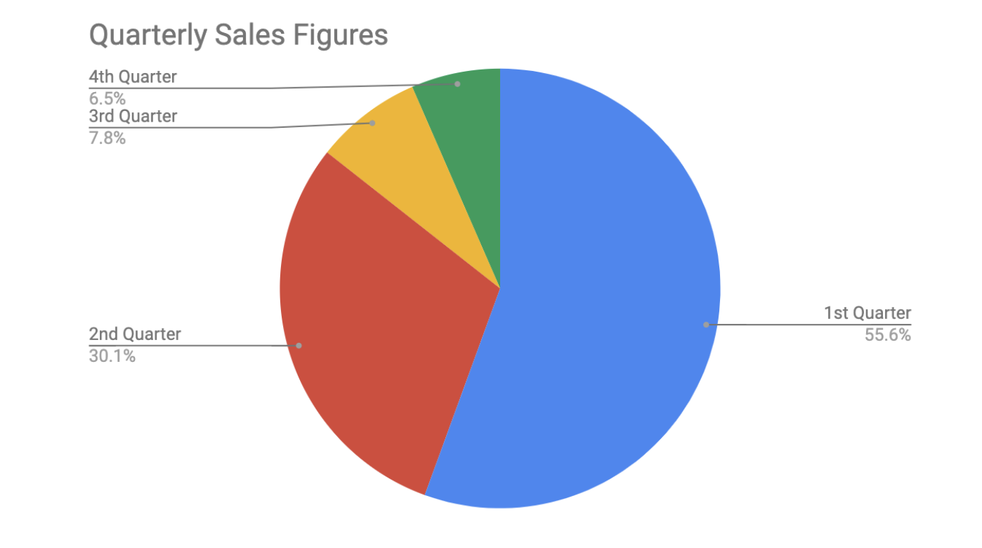

* **Are you measuring changes over time?** A line chart is usually adequate for plotting trends over time. However, when the changes are larger, a bar chart is the better option. If, for example, you are measuring the number of visitors to NYC over the past 6 months, the data would look like this:

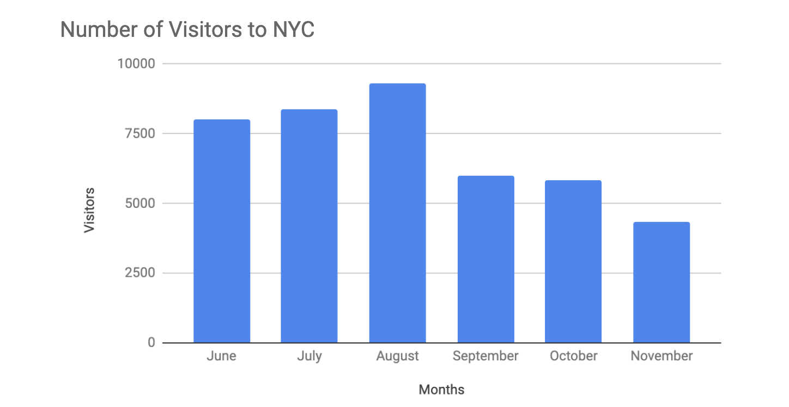

* **Do relationships between the data need to be shown? When you have two variables for one set of data, it is important to point out how one affects the other. Variables that pair well together are best plotted on a scatter plot**.

**However**, if there are **too many data points**, the relationship between variables can be obscured **so a heat map can be a better representation in that case**. If you are measuring the population of people across all 50 states in the United States, your data points would consist of millions so you would use a heat map. If you are simply trying to show the relationship between the number of hours spent studying and its effects on grades, your data would look like this:

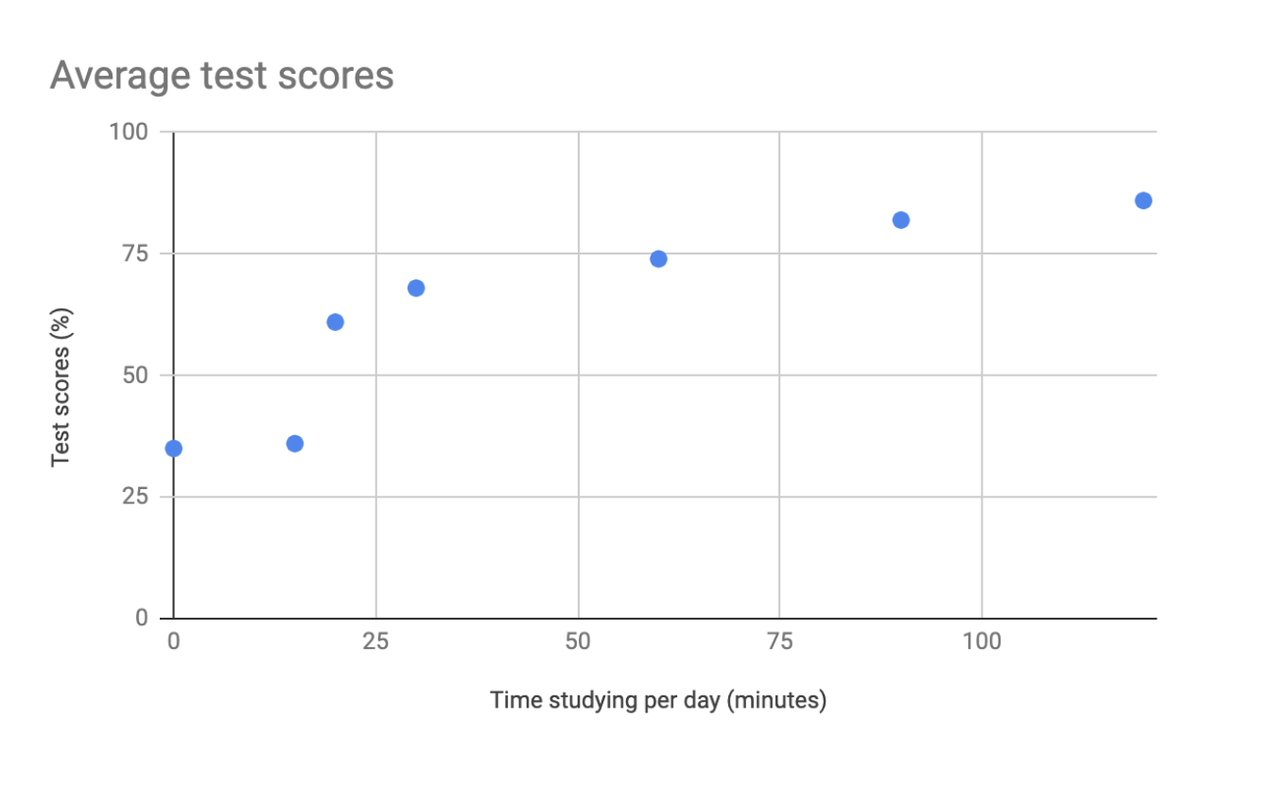

## **Additional resources**

The decision tree example used in this reading is one of many. There are multiple decision trees out there with varying levels of details that you can use to help guide your visual decisions. If you want more in-depth insight into more visual options, explore the following resources:

* [From data to visualization](https://www.data-to-viz.com/): This is an excellent analysis of a larger decision tree. With this comprehensive selection, you can search based on the kind of data you have or click on each graphic example for a definition and proper usage.
* [Selecting the best chart](https://www.youtube.com/watch?v=C07k0euBpr8): This two-part YouTube video can help take the guesswork out of data chart selection. Depending on the type of data you are aiming to illustrate, you will be guided through when to use, when to avoid, and several examples of best practices. [Part 2](https://www.youtube.com/watch?v=qGaIB-bRn-A) of this video provides even more examples of different charts, ensuring that there is a chart for every type of data out there.

[SELF-REFLECTION: CHOOSE YOUR VISUALIZATION TYPE](https://www.coursera.org/learn/visualize-data/quiz/L1Tds/self-reflection-choose-your-visualization-type)



## **Activity Overview**



Now that you’ve been introduced to decision trees, pause for a moment and practice what you’ve been learning. In this self-reflection, you’ll first review decision trees and data visualization best practices. Then, you’ll examine a scenario, use a decision tree to determine the most effective chart type based on the scenario, and respond to brief questions.

This self-reflection will help you develop insights into your own learning and prepare you to use a decision tree to help you plan your next visualization. As you answer questions—and come up with questions of your own—you will consider concepts, practices, and principles to help refine your understanding and reinforce your learning. Answering and asking questions in this self-reflection will help to reinforce what you’ve learned so far, so it will be easier for you to remember it later.

Next, review decision tree uses, concepts, and best practices.

### **Review decision tree uses, concepts, and best practices**

**Decision tree uses**

A decision tree is a flowchart that you can use to help frame larger decisions as a series of smaller yes/no decisions. These are useful when trying to choose the best data visualization to communicate a given message to your audience. Because different visualizations have different strengths and weaknesses, a decision tree can help you pick the best visualization for your data and audience. Here’s the decision tree you examined earlier in this course:

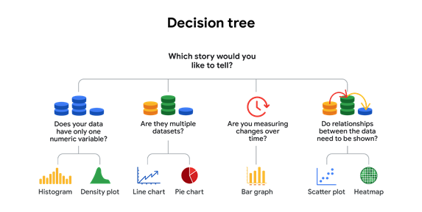

Path 1: Does your data have only one numeric variable? If so, choose a histogram or a density plot. Path 2: Are they multiple datasets? If so, choose a line chart or a pie chart. Path 3: Are you measuring changes over time? If so, choose a bar chart. Path 4: Do relationships between data need to be shown? If so, choose a scatterplot or a heatmap.

**Decision tree concepts and best practices**

Before you use the decision tree in a scenario to create successful data visualizations, take a moment to review some of the design concepts and best practices you’ve learned so far. Recall that there are four elements of successful data visualization:

* Information: reflects the conclusion you’ve drawn from the data, which you will communicate with visualization
* Story: adds meaning to the data and makes it interesting
* Goals: makes the data usable and useful
* Visual form: creates both beauty and structure

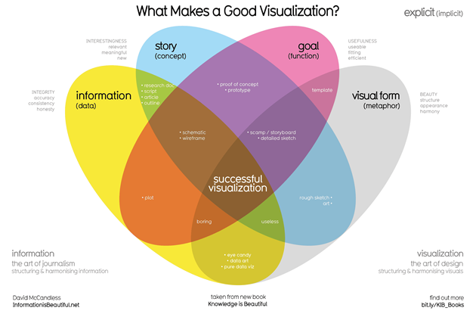

Keep these elements in mind as you review the scenario below. This will help you make better data visualizations by helping you connect the information you want to communicate with your audience and your goals.

**Here are some additional best practices to keep in mind:**

* **Your audience should know what they are observing within five seconds of being shown a data visualization. Visuals should be clear and easy to follow.**
* **In the five seconds after that, your audience should understand the conclusion your visualization is making—even if they aren’t familiar with your research.**
* **As long as it’s not misleading, you should visually represent only the data that your audience needs to understand your findings. Including irrelevant data may confuse, distract, or overwhelm your audience.**

**These rules will guide you as you create your visualizations and you can apply them as you consider the following scenario.**

### 

### ***Scenario***

You’re a junior data analyst at a local retailer. In your current data analysis project, you’ve been exploring sales data for all of your company’s products, including the top products and sales trends for the last year. You need to present the results of this analysis to the company executives. Your goal for this presentation is to demonstrate how sales of the company’s products have changed over the last 12 months. Your findings about the two top-selling products include: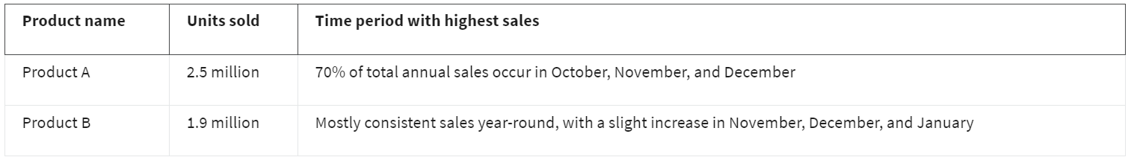Your audience is the chief marketing officer (CMO) and marketing department vice presidents (VPs), not other data analysts or engineers. The audience will use the information you present to make decisions on how to allocate the advertising budget for each product for the coming year.Now, use the decision tree.

### Use the decision tree

Consider what you know about the type of data you have (product sales data) and the kind of relationships you are trying to communicate (time periods with the most sales). Use this information to navigate the decision tree and use it to determine what type of visualization would be most appropriate.

Based on how you want to represent the sales data, there are several choices that would result in a successful chart. You could frame this by using a comparison of different categories with a bar graph or by showing how the composition of total sales changes month-to-month as a line chart with lines for each product.

Either of these would be a successful choice. Combined with effective use of design principles, either could accurately communicate the message you need to convey to company leadership. This message being: Sales for Product A are extremely seasonal, so they may want to consider reducing their advertising spend for this product when it’s out of season.

[TEST YOUR KNOWLEDGE ON DATA VISUALIZATIONS](https://www.coursera.org/learn/visualize-data/quiz/CbiAX/test-your-knowledge-on-data-visualizations)

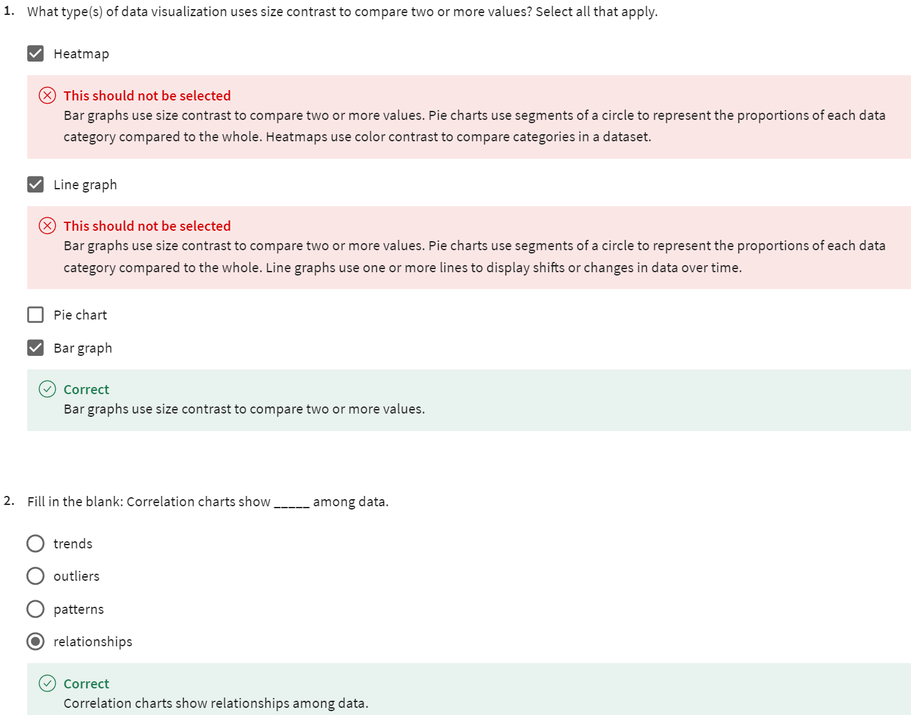

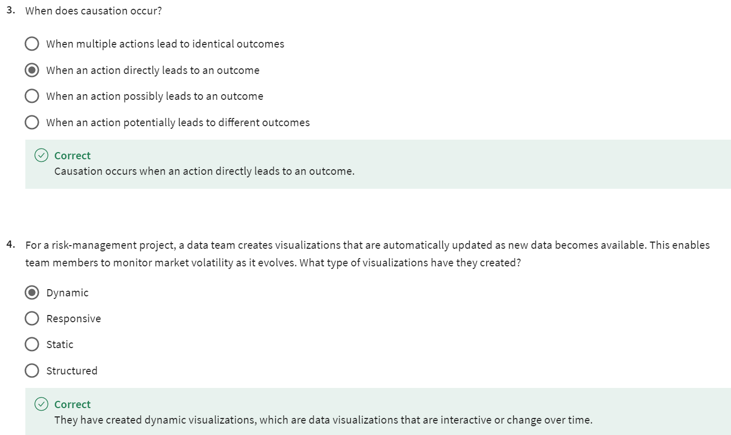

DESIGN DATA VISUALIZATIONS

[ELEMENTS OF ART](https://www.coursera.org/learn/visualize-data/lecture/ja0Ab/elements-of-art)

You probably didn't think you'd be learning about art in a data analytics course, but that's exactly what we're going to do.

Both data analysts and artists use elements of art in their work. We'll introduce those elements to you here, and we'll show you how to apply them to visualizations later.

The elements we'll check out are line, shape, color, space and movement.

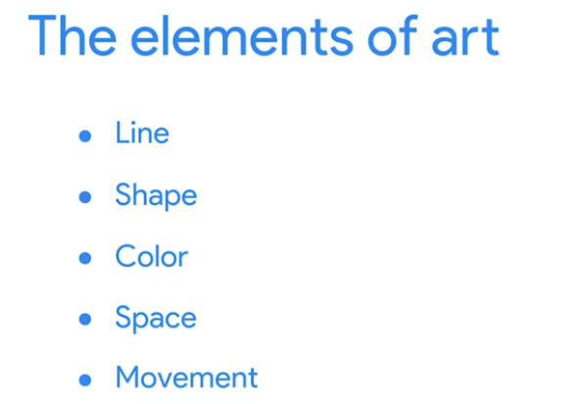

Now, these aren't the only elements to consider, but these particular ones can add value to your data viz by making them more visually effective and compelling. Lines and visualizations can be curved or straight, thick or thin, vertical, horizontal, or diagonal.

They can add visual form to your data and help build a structure for your visualization. These charts show some of the variety that lines can bring to your data viz.

The combo chart shows two different types of lines, both providing a graphic for the data. The line chart does the same, but uses curved lines instead. Shapes are also known for their variety. **Shapes** and visualizations should always be two-dimensional. This is because three-dimensional objects in a visualization can complicate the visual and confuse the audience. **Shapes** are also a great way to add eye-catching contrast, especially size contrast to your data story.

This circle used for a pie chart lets someone quickly understand the data in a familiar format. 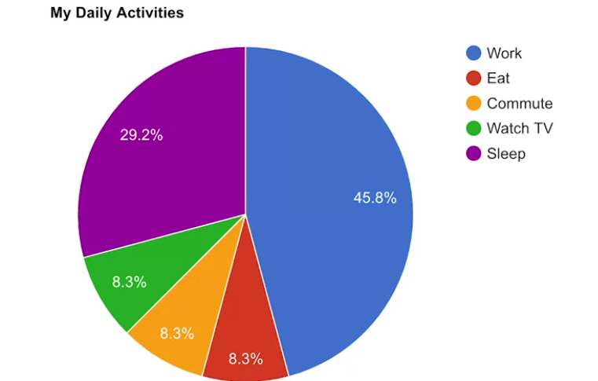

**Shapes** with symmetry are usually more familiar to people, so there's less work for the audience to do when viewing symmetrical data viz.

But the asymmetrical **shapes** in this map are still instantly recognizable as countries.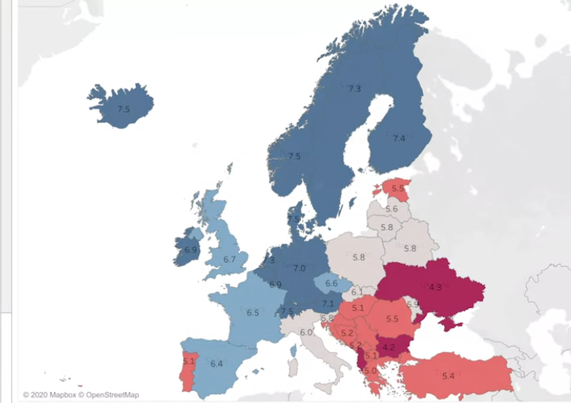

It's good to note that the data you're sharing with your audience will usually inform the types of shapes you want to use in your data viz.

Next, we have **colors**, and colors are, well, colors. Of course, in the eyes of artists and analysts, colors can be much more complex. **Colors** can be described by their **hue**, **intensity**, and **value**.

The **hue** of a color is basically its name, red, green, blue and so on. **Intensity** is how bright or dull a color is, and finally, there's **value**.

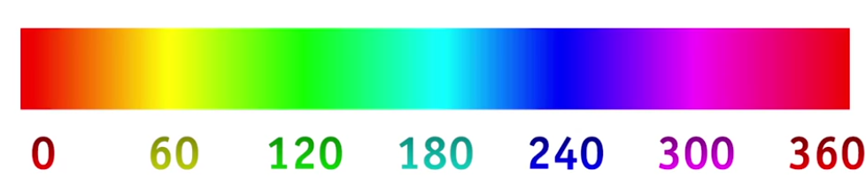

The **value** is how light or dark the colors are in a visualization. In more scientific terms **value indicates how much light is being reflected.**

Dark values with some black added are called shades of color, like these shades of green.

Light values with white added are called tints, like these tints of blue.

In this map, there are shades and tints of gray.

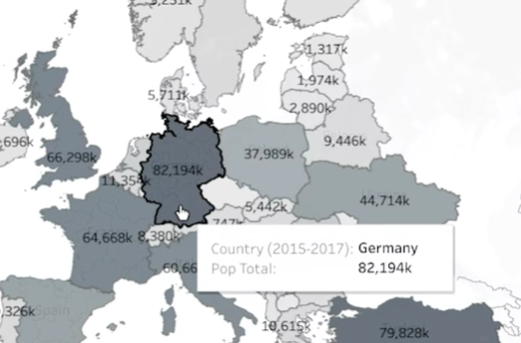

The value of these colors help us understand the population data in the map and varying the color's value can be a very effective way to draw our audience's attention to specific areas.

**Space** is the area between, around and in the objects. There should always be space in data visualizations, just not too much or too little. For example, the space between the bars of a bar graph like this one should be smaller than the width of the bars themselves.

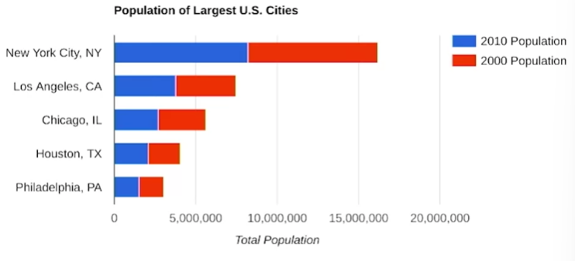

This will draw the viewer's attention to the bar and the data it represents instead of the empty space.

Finally, there's **movement**.

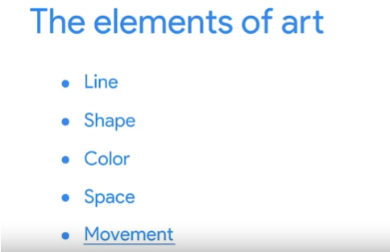

**Movement** is used to create a sense of flow or action in a visualization.

One of my favorite examples is the data viz, the Wealth and Health of Nations.

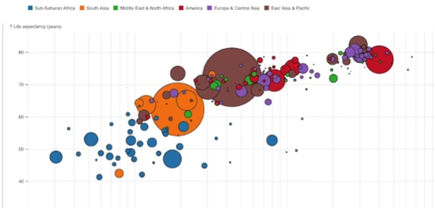

This viz showcases a correlation between the financial health and physical health of nations. It traces these elements over time so you can see how the two correlated effects play out. The movement pulls in data from the 1800s all the way up until recently. The interactivity allows for a greater volume of data to be displayed and we'll reveal multiple stories from the same data visualization.

Remember, this is something that should be used sparingly. **There's a fine line between attracting attention and distracting the audience**.

A static image lets you control all elements of the story you want to tell. When you start incorporating movement and interactivity, the story is controlled by whoever is controlling the interactivity, whether that's you or possibly your audience if you've turned control over to them. We'll discuss this delicate balance later on in the course.

[PRINCIPLES OF DESIGN](https://www.coursera.org/learn/visualize-data/supplement/Ijxn6/principles-of-design)

In this reading, you are going to learn more about using the elements of art and principles of design to create effective visualizations. So far, we have learned that communicating data visually is a form of art. Now, it's time to explore the nine design principles for creating beautiful and effective data visualizations that can be informative and appeal to all audiences.

After we go through the various design principles, spend some time examining the visual examples to ensure that you have a thorough understanding of how the principle is put into practice. Let’s get into it!

## 

## **Nine basic principles of design**

There are ninebasic **principles of design** that data analysts should think about when building their visualizations.

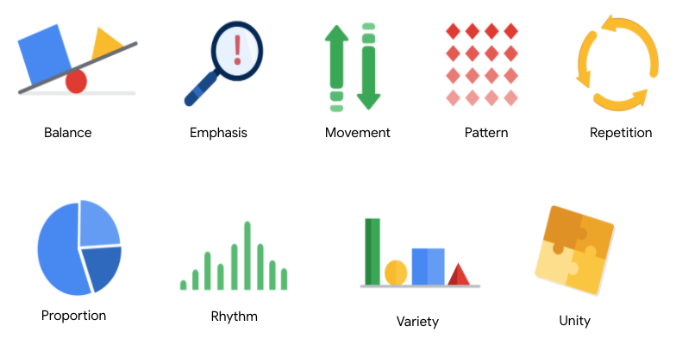

**1. Balance**: The design of a data visualization is balanced when the key visual elements, like color and shape, are distributed evenly. This doesn’t mean that you need complete symmetry, but your visualization shouldn’t have one side distracting from the other. If your data visualization is balanced, this could mean that the lines used to create the graphics are similar in length on both sides, or that the space between objects is equal. For example, [**this column chart**](https://developers.google.com/chart/interactive/docs/gallery/columnchart) (also shown below) is balanced; even though the columns are different heights and the chart isn’t symmetrical, the colors, width, and spacing of the columns keep this data visualization balanced. The colors provide sufficient contrast to each other so that you can pay attention to both the motivation level and the energy level displayed.

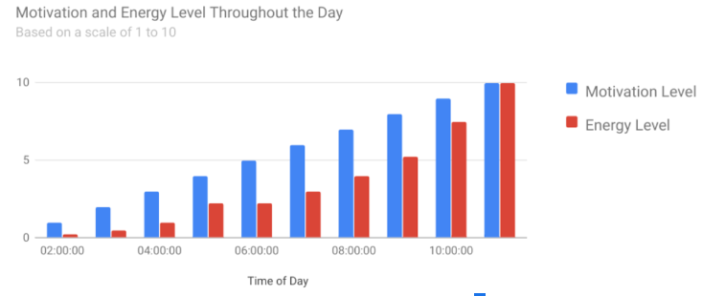

**2. Emphasis:** Your data visualization should have a focal point, so that your audience knows where to concentrate. In other words, your visualizations should emphasize the most important data so that users recognize it first. Using color and value is one effective way to make this happen. By using contrasting colors, you can make certain that graphic elements—and the data shown in those elements—stand out.

For example, you will notice a heat map data visualization below from [**The Pudding’s “Where Slang Comes From"**](https://pudding.cool/2017/02/new-slang/)article. This heat map uses colors and value intensity to emphasize the states where search interest is highest. You can visually identify the increase in the search over time from low interest to high interest. This way, you are able to quickly grasp the key idea being presented without knowing the specific data values.

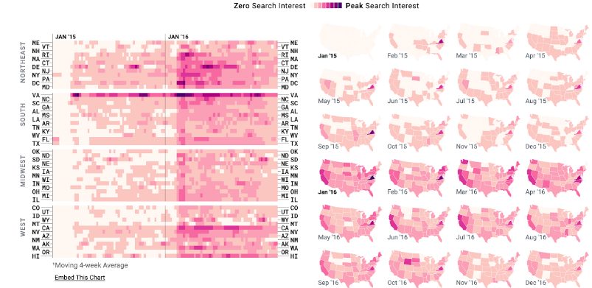

**3. Movement:** Movement can refer to the path the viewer’s eye travels as they look at a data visualization, or literal movement created by animations. Movement in data visualization should mimic the way people usually read. You can use lines and colors to pull the viewer’s attention across the page.

For example, notice how the average line in [**this combo chart**](https://developers.google.com/chart/interactive/docs/gallery/combochart) (also shown below) draws your attention from left to right. Even though this example isn’t moving, it still uses the movement principle to guide viewers’ understanding of the data.

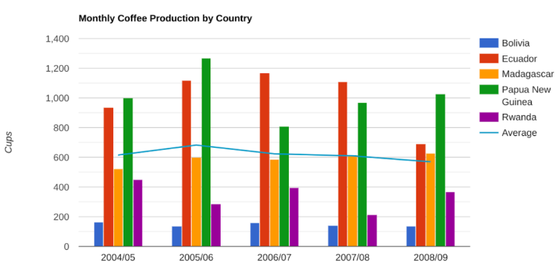

**4. Pattern:** You can use similar shapes and colors to create patterns in your data visualization. This can be useful in a lot of different ways.

For example, you can use patterns to highlight similarities between different data sets, or break up a pattern with a unique shape, color, or line to create more emphasis.

In the example below, the different colored categories of [**this stacked column chart**](https://developers.google.com/chart/interactive/docs/gallery/barchart)(also shown below)are a consistent pattern that makes it easier to compare book sales by genre in each column. Notice in the chart that the Fantasy & Sci Fi category (royal blue) is increasing over time even as the general category (green) is staying about the same.

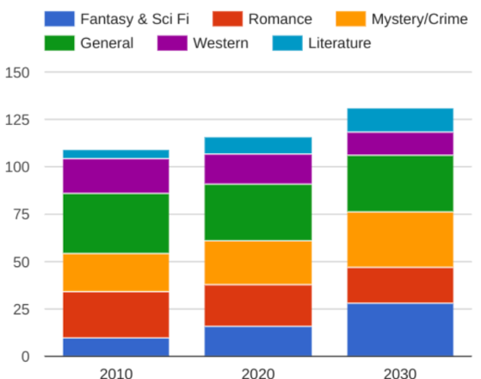

**5. Repetition:** Repeating chart types, shapes, or colors adds to the effectiveness of your visualization. Think about the book sales chart from the previous example: the repetition of the colors helps the audience understand that there are distinct sets of data. You may notice this repetition in all of the examples we have reviewed so far. Take some time to review each of the previous examples and notice the elements that are repeated to create a meaningful visual story.

**6. Proportion:** Proportion is another way that you can demonstrate the importance of certain data. Using various colors and sizes helps demonstrate that you are calling attention to a specific visual over others. If you make one chart in a dashboard larger than the others, then you are calling attention to it. It is important to make sure that each chart accurately reflects and visualizes the relationship among the values in it. In [**this dashboard**](https://developers.google.com/chart/interactive/docs/gallery/controls) (also shown below), the slice sizes and colors of the pie chart compared to the data in the table help make the number of donuts eaten by each person the focal point.

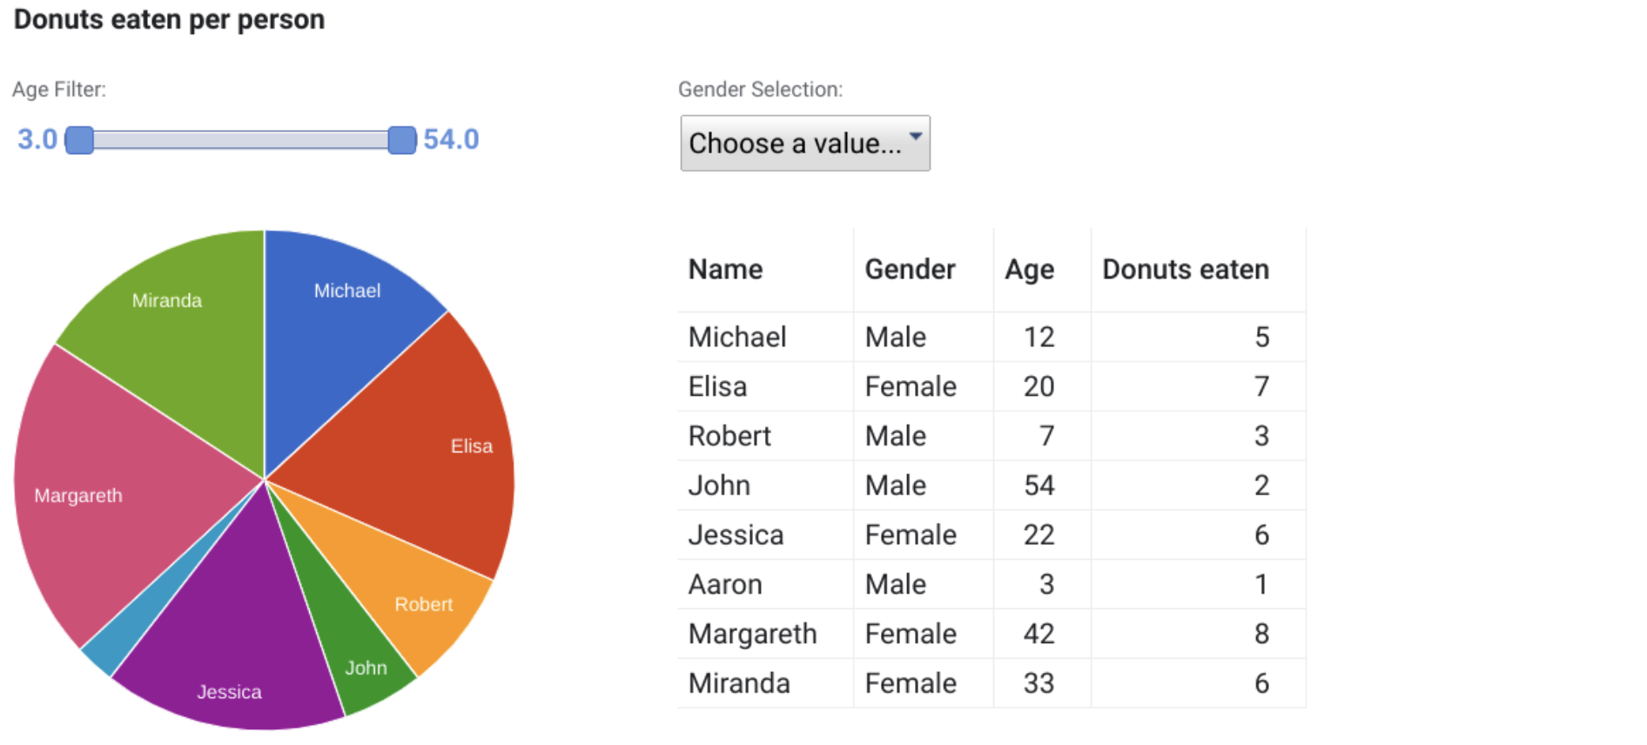

**These first six principles of design are key considerations** that you can make **while you are creating your data visualization**. These next three principles are useful checks once your data visualization is finished. If you have applied the initial six principles thoughtfully, then you will probably recognize these next three principles within your visualizations already.

Abreviação dos 6 primeiros princípios básicos do Design =>  **B-E-M-P-R-P**

**7. Rhythm:** This refers to creating a sense of movement or flow in your visualization. Rhythm is closely tied to the movement principle. If your finished design doesn’t successfully create a flow, you might want to rearrange some of the elements to improve the rhythm.

**8. Variety:** Your visualizations should have some variety in the chart types, lines, shapes, colors, and values you use. Variety keeps the audience engaged. But it is good to find balance since too much variety can confuse people. The variety you include should make your dashboards and other visualizations feel interesting and unified.

**9. Unity:** The last principle is unity. This means that your final data visualization should be cohesive. If the visual is disjointed or not well organized, it will be confusing and overwhelming.

Being a data analyst means learning to think in a lot of different ways. These nine principles of design can help guide you as you create effective and interesting visualizations.

[DATA VISUALIZATION IMPACT](https://www.coursera.org/learn/visualize-data/lecture/pzUSm/data-visualization-impact)

Hopefully by now we've developed a clear picture of data viz. We've explored everything from design principles to the types of charts you can use in your visualizations. Choosing the right visualization for your data findings can often come down to one question.

**Which one will make it easiest for the user to understand the point you're trying to make?**

No matter how complex your analysis is, your audience will only care about what's in front of them and how easy they can understand it. As you complete your analysis, you'll have to decide which visualization serves your needs and your audience's needs for each task.

For example, if you want to show a comparison of the different age groups of visitors to a website, a line graph with a line for each age group, plus one for total users would work well.

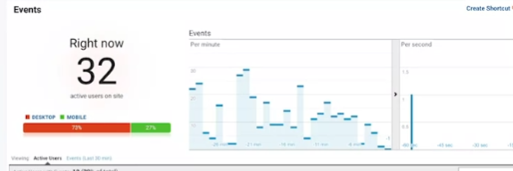

Let's say you want to highlight the differences among the age groups to compare them or directly, for that you might use a positive negative bar chart like this.

You've worked with some of these before and will cover more about charts with more examples later. You'll also discover that the best charts to suit your purposes might depend on the needs of your industry, and company, and the stakeholders who will be in your audience.

For **comparing data over time** we showed you how line graphs could be effective. Like in this one bar graphs and stacked bar graphs, along with area charts, can also be **good ways to visualize how data changes over time**.

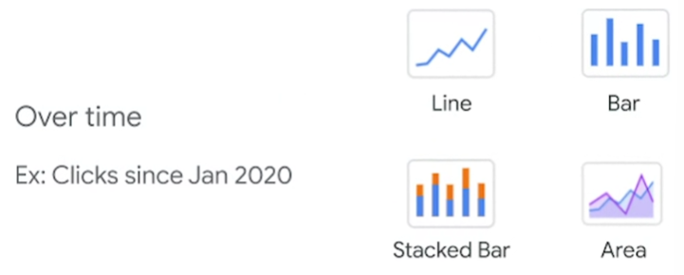

By the way, there's a lot of charts out there, we'll give you as much information as possible about as many as we can. But doing your own research or practicing using them in visualizations will also be helpful.

Okay, when you're **comparing distinct objects** like in our example about mobile versus computer usage, ordered bar, and group bar graphs, and ordered column charts are useful.

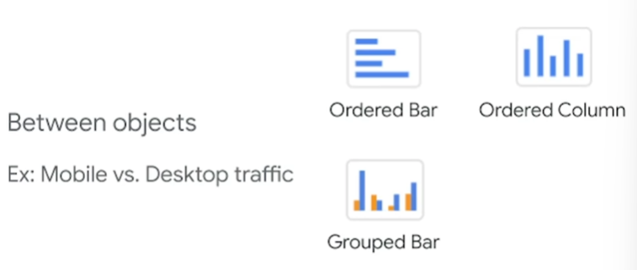

Then there's charts that show parts of a whole. This is known as **data composition**, and it's achieved by combining the individual parts of a visualization and displaying them together as a whole.

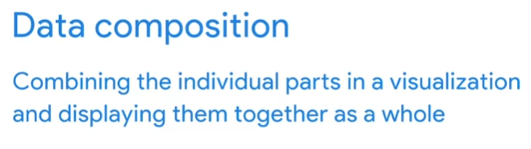

Stack bars, donuts, stacked areas, pie charts and tree maps can do all this.

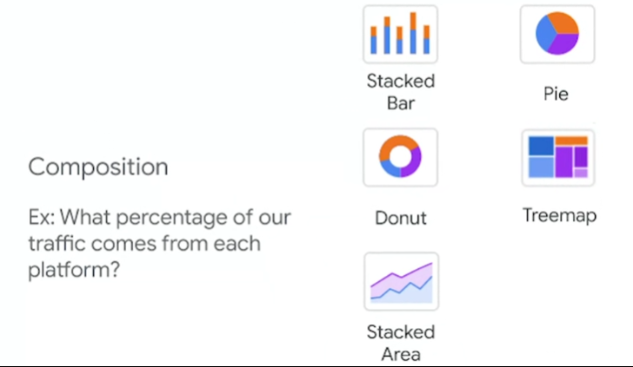

Now **to show relationships in your data**, you might want to use scatter plot and bubble charts, column/line charts and heatmaps. Let's revisit the happiness data vis to show you an example of this.

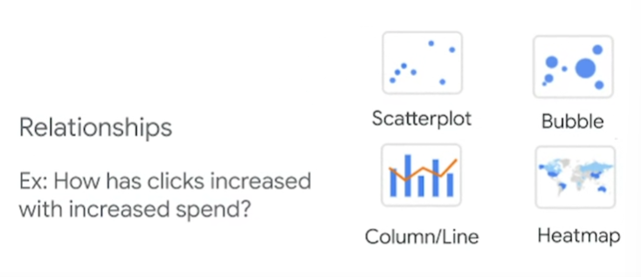

Each of these scatterplots show the relationship between a country's happiness score and one of the factors that contributes to that score.

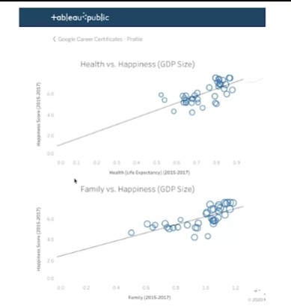

So the health versus happiness scatterplot shows a strong relationship between the life expectancy of people living in a country and how happy those people are. Basically, as life expectancy increases, so does their happiness score. Speaking of happiness, a successful data visualization results in a happy audience.

So it's important to understand how your audience is viewing your data visualizations, since they should always be top of mind. And it all starts in the brain, when processing information our brains try to find patterns and rely on visual context. As data analysts, we can use our understanding of the human visual system to produce better visuals. When we create visualizations, we can do so in a way that helps the audience process the information and helps them remember what they're seeing. Visual journalist **Dona Wong** proposes that effective visuals, like the database we've been discussing here, have **three essential elements**.

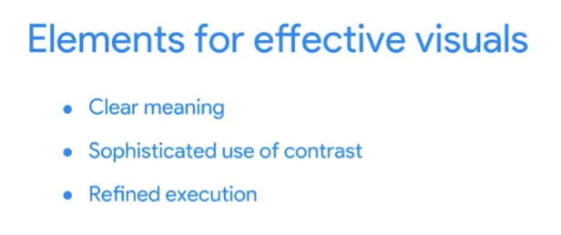

The **first** is clear meaning, good visualizations clearly communicate their intended insight.

The **second** is a sophisticated use of contrast, which helps separate the most important data from the rest using visual context that our brains naturally look for.

The **third** essential element for effective visuals is refined execution. Visuals with refined execution include deep attention to detail, using visual elements like lines, shapes, colors, value, space and movement. In other words, the elements of art that we talked about earlier.

**The first rule in most businesses is to satisfy the customer, it's no different with data analytics**. While your customers will probably be managers and other stakeholders, you should always think of them first when creating data visualizations.

Think about the five second rule we called out earlier. If you make your data viz easy to look at and understand quickly, then you have done your job and then you'll be satisfied just like your customers.

[DATA IS BEAUTIFUL](https://www.coursera.org/learn/visualize-data/supplement/Z2Ox1/data-is-beautiful)

At this point, you might be asking yourself: What makes a good visualization? Is it the data you use? Or maybe it is the story that it tells? In this reading, you are going to learn more about what makes data visualizations successful by exploring David McCandless’ elements of successful data visualization and evaluating three examples based on those elements. Data visualization can change our perspective and allow us to notice data in new, beautiful ways. **A picture is worth a thousand words—that’s true in data too!** You will have the option to save all of the data visualization examples that are used throughout this reading; these are great examples of successful data visualization that you can use for future inspiration.

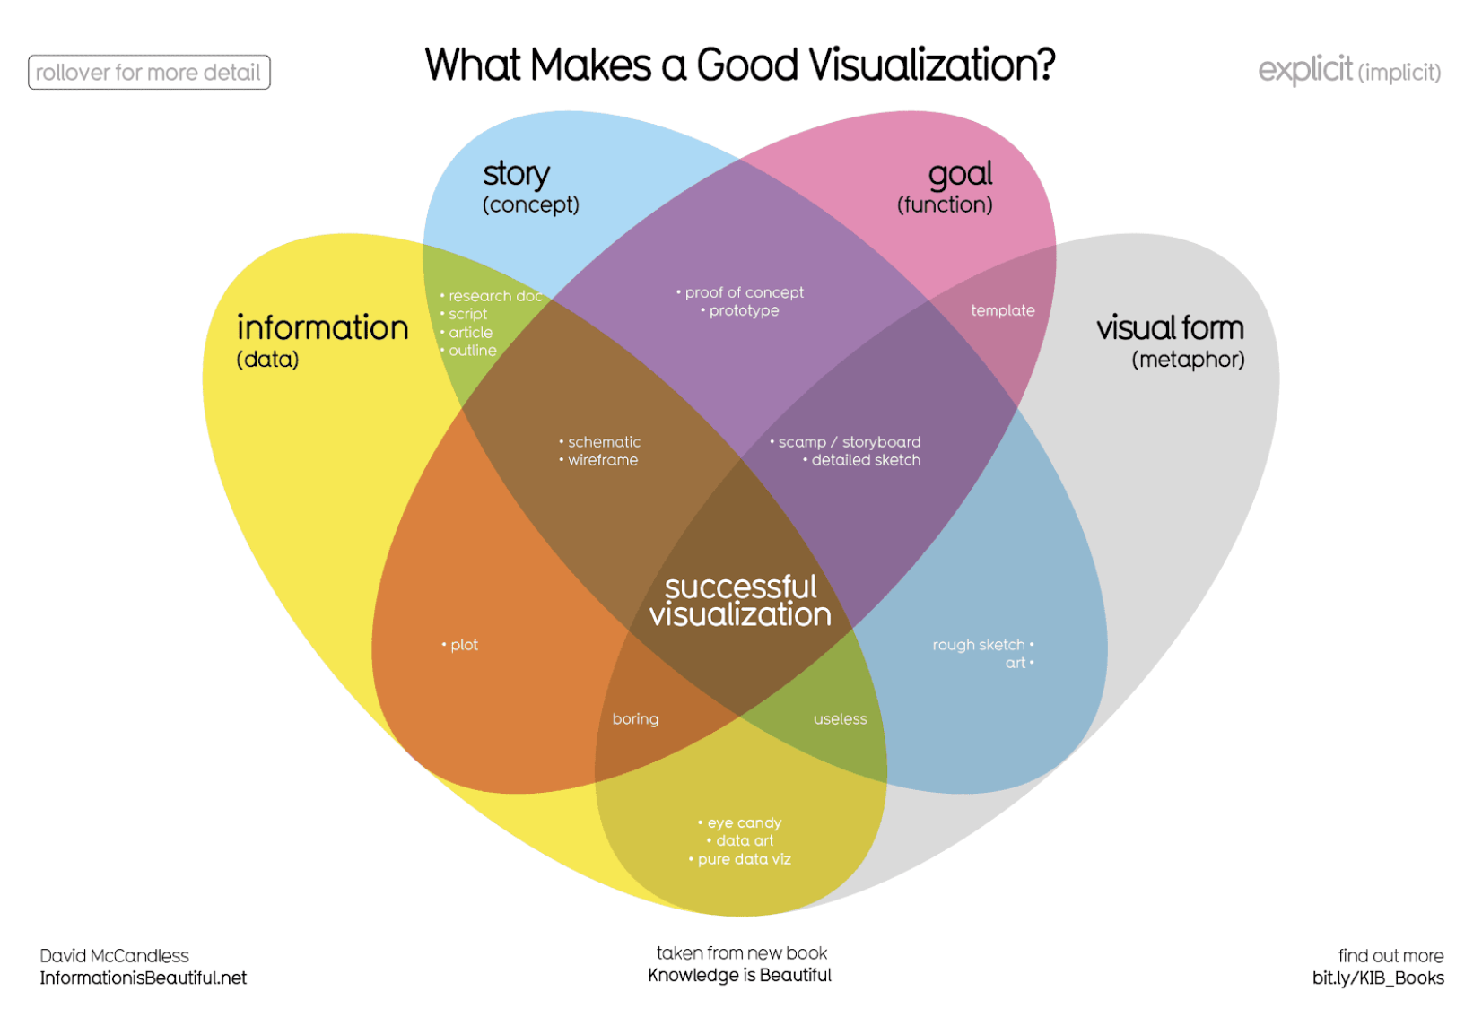

Where just two or three ovals overlap, there are different types of incomplete data visualization. At the center, where all four overlap, contains the words “successful visualization”. This visualization stresses the idea that all four elements are necessary to create a successful data visualization

You can also access a .pdf version of this visualization and save it for your own reference by clicking the file below:

[WEB_What-Makes-a-Good-Infoviz.pdf](https://d3c33hcgiwev3.cloudfront.net/P5sik46MQMmbIpOOjGDJ0g_6ccbbc544b41477883b63dd5f37dbbf5_WEB_What-Makes-a-Good-Infoviz.pdf?Expires=1714608000&Signature=ODI2nbvCIgGZDiQls4SL-vjrjL7r8SHaLqXB2IxOjSLlbwFLGkslfrWMjyeADdeSOzhJOJVBBZEHtHZRo-pgUj63pzl307FFmqTf7R~gURqtYA1Il3fQia0MWD1CVOU3R4-n5BKaSkzCQgRWUZg~OTwt6sq0wfIFDXcU2R2-XPY_&Key-Pair-Id=APKAJLTNE6QMUY6HBC5A)

**Four elements of successful visualizations**

The Venn diagram by David McCandless identifies four elements of successful visualizations:

* **Information (data):** The information or data that you are trying to convey is a key building block for your data visualization. Without information or data, you cannot communicate your findings successfully.
* **Story (concept):** Story allows you to share your data in meaningful and interesting ways. Without a story, your visualization is informative, but not really inspiring.
* **Goal (function):** The goal of your data visualization makes the data useful and usable. This is what you are trying to achieve with your visualization. Without a goal, your visualization might still be informative, but can’t generate actionable insights.
* **Visual form (metaphor):** The visual form element is what gives your data visualization structure and makes it beautiful. Without visual form, your data is not visualized yet.

All four of these elements are important on their own, but a successful data visualization balances all four. For example, if your data visualization has only two elements, like the information and story, you have a rough outline. This can be really useful in your early planning stages, but is not polished or informative enough to share. Even three elements are not quite enough—you need to consider all four to create a successful data visualization.

In the next part of this reading, you will use these elements to examine two data visualization examples and evaluate why they are successful.

## **Example 1: Visualization of dog breed comparison**

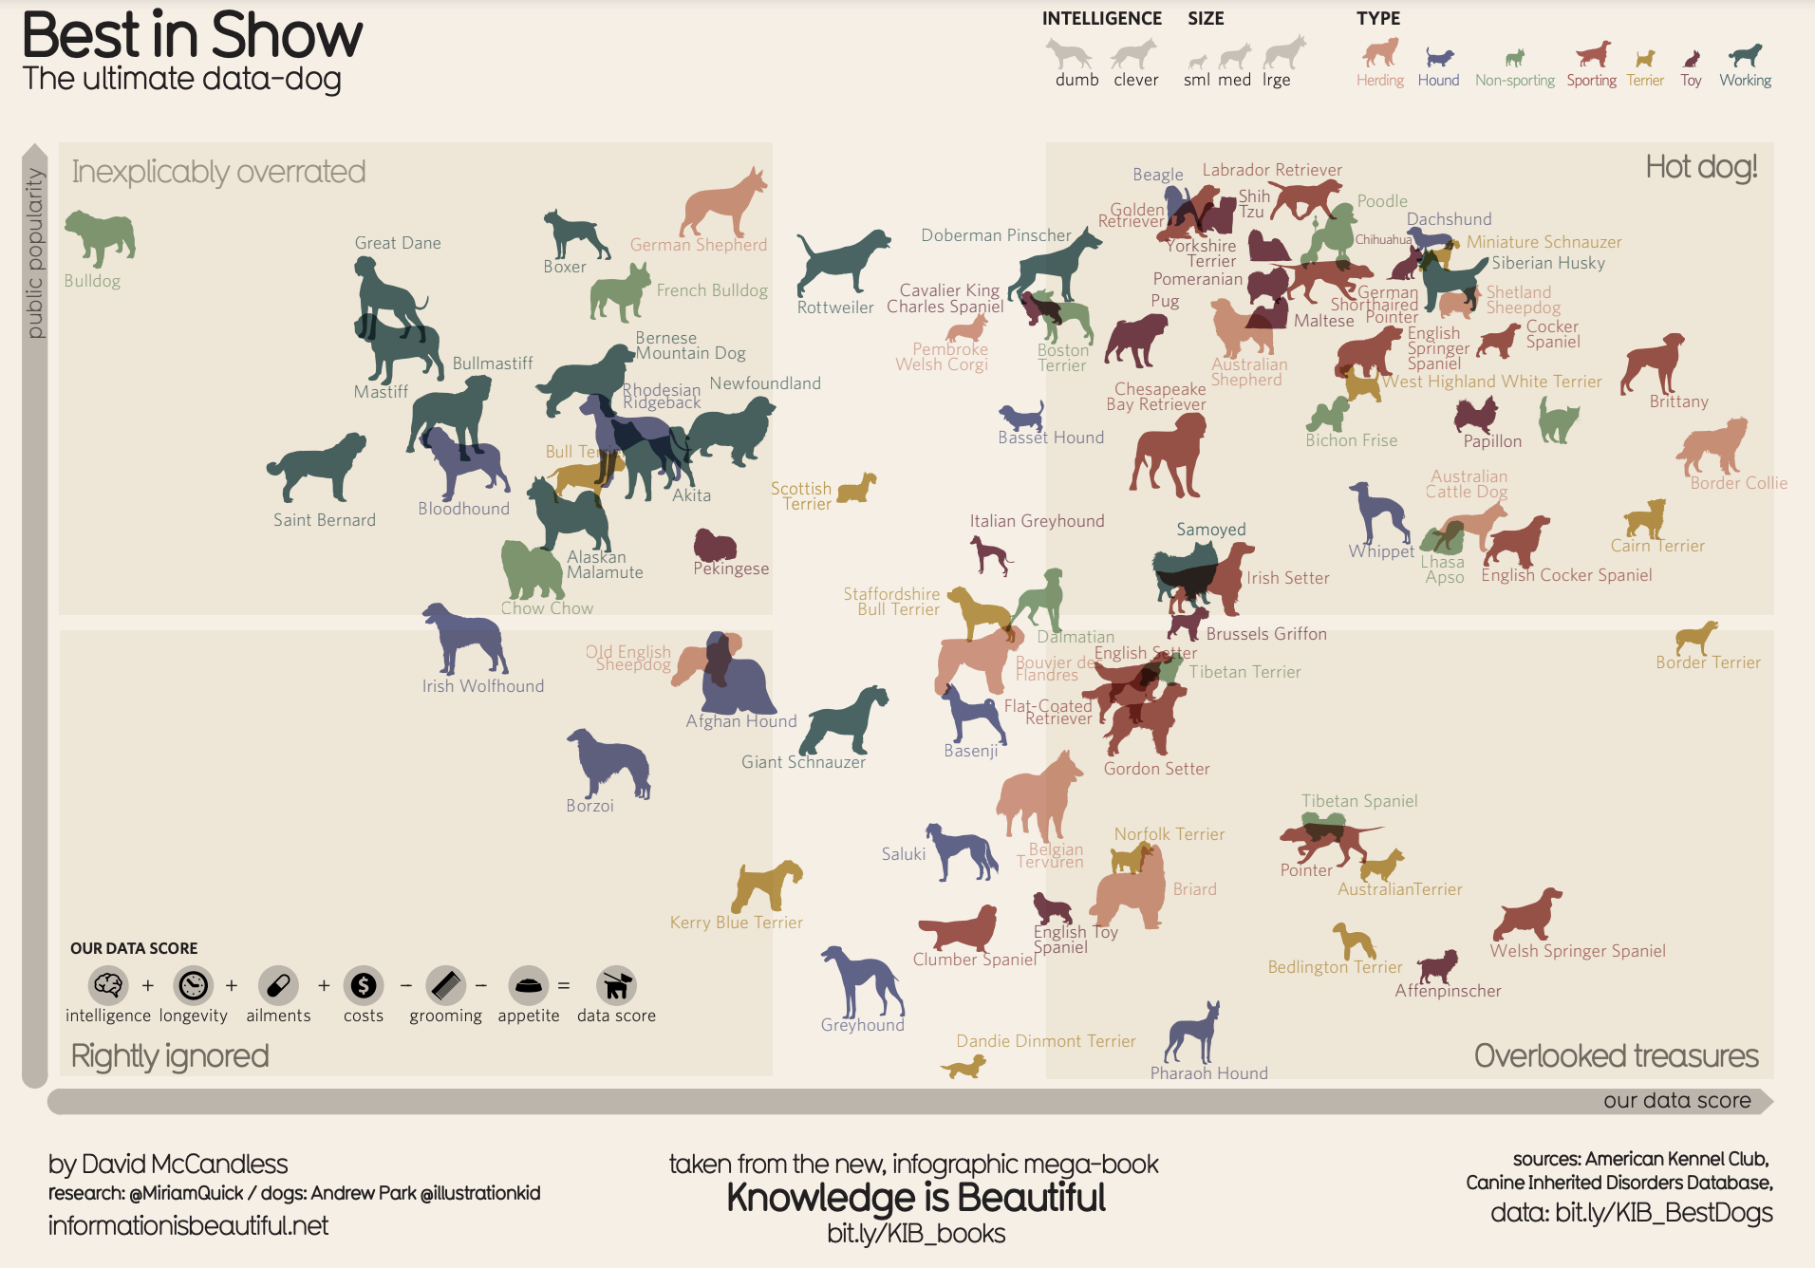

It uses two axes, popularity and data score, to place different dog breeds on a four-square chart. The squares are labeled “Inexplicably Overrated,” “The Rightly Ignored,” “Hot Dogs!,” and “Overlooked Treasures.” Different dog breeds, visualized with plotted points shaped like dogs, are distributed on the chart based on their popularity and their data score.

Save this data visualization as a .pdf by clicking the file below:

[IIB-LICENSED_Best-in-Show.pdf](https://d3c33hcgiwev3.cloudfront.net/9_ukt6X2QOu7pLel9tDrfw_359529dc0bd647de843a11274ca5ace9_IIB-LICENSED_Best-in-Show.pdf?Expires=1714608000&Signature=cYfea~05cuaQURyB~6T1tVAvkVBgepjbLbYuXXKjFrH3dZ7Ixx~EDir0OC3c7U7UqEZCaxYY~UuiW-DRID0OzEEzaJex8gC5tOelYjJZfAWoYfCsJ7MPlzI0rmMr46-4LJRSXNiVtaT4Q58vpUximnkOTK6SKelKpJmocetlT34_&Key-Pair-Id=APKAJLTNE6QMUY6HBC5A)

### **View the data**

The Best in Show visualization uses data about different dog breeds from the American Kennel Club. The data has been compiled in a spreadsheet. Click the link below and select "Use Template" to view the data.

Link to the template: [KIB - Best in Show](https://docs.google.com/spreadsheets/d/1cbqOIishrWTrfSgxjCrdua-m91B67Qls/edit?usp=share_link&ouid=100233597079733080159&rtpof=true&sd=true)

Or, if you don't have a Google account, download the file below.

[KIB - Best in Show (public)](https://d3c33hcgiwev3.cloudfront.net/-tlQpnbgR2-ZUKZ24GdvPg_5754482a15824030bab88668386dde06_KIB---Best-in-Show-public-.xlsx?Expires=1714608000&Signature=WCtHj7UFmaoVtes1EVlprRKg-eAs6CYk4ctYNzUSkTE-uSR1eyXmfamjZG3ViJYbyixMGY4Sjx-VhbCrH~vhkDC2aS9tMkPVU2E3Bv~XKR2fA9Oy97-sTgujoaIvMHQSk3nzAyCZ6Wrq3YmaS43GjO7ZSQlelX5z3-6OuoIdJhU_&Key-Pair-Id=APKAJLTNE6QMUY6HBC5A)

### 

### **Examine the four elements**

This visualization compares the popularity of different dog breeds to a more objective data score. Consider how it uses the elements of successful data visualization:

* **Information (data):** If you view the data, you can explore the metrics being illustrated in the visualization.
* **Story (concept):** The visualization shows which dogs are overrated, which are rightly ignored, and those that are really hot dogs! And, the visualization reveals some overlooked treasures you may not have known about previously.
* **Goal (function):** The visualization is interested in exploring the relationship between popularity and the objective data scores for different dog breeds. By comparing these data points, you can learn more about how different dog breeds are perceived.
* **Visual form (metaphor):** In addition to the actual four-square structure of this visualization, other visual cues are used to communicate information about the dataset. The most obvious is that the data points are represented as dog symbols. Further, the size of a dog symbol and the direction the dog symbol faces communicate other details about the data.

## **Example 2: Visualization of rising sea levels**

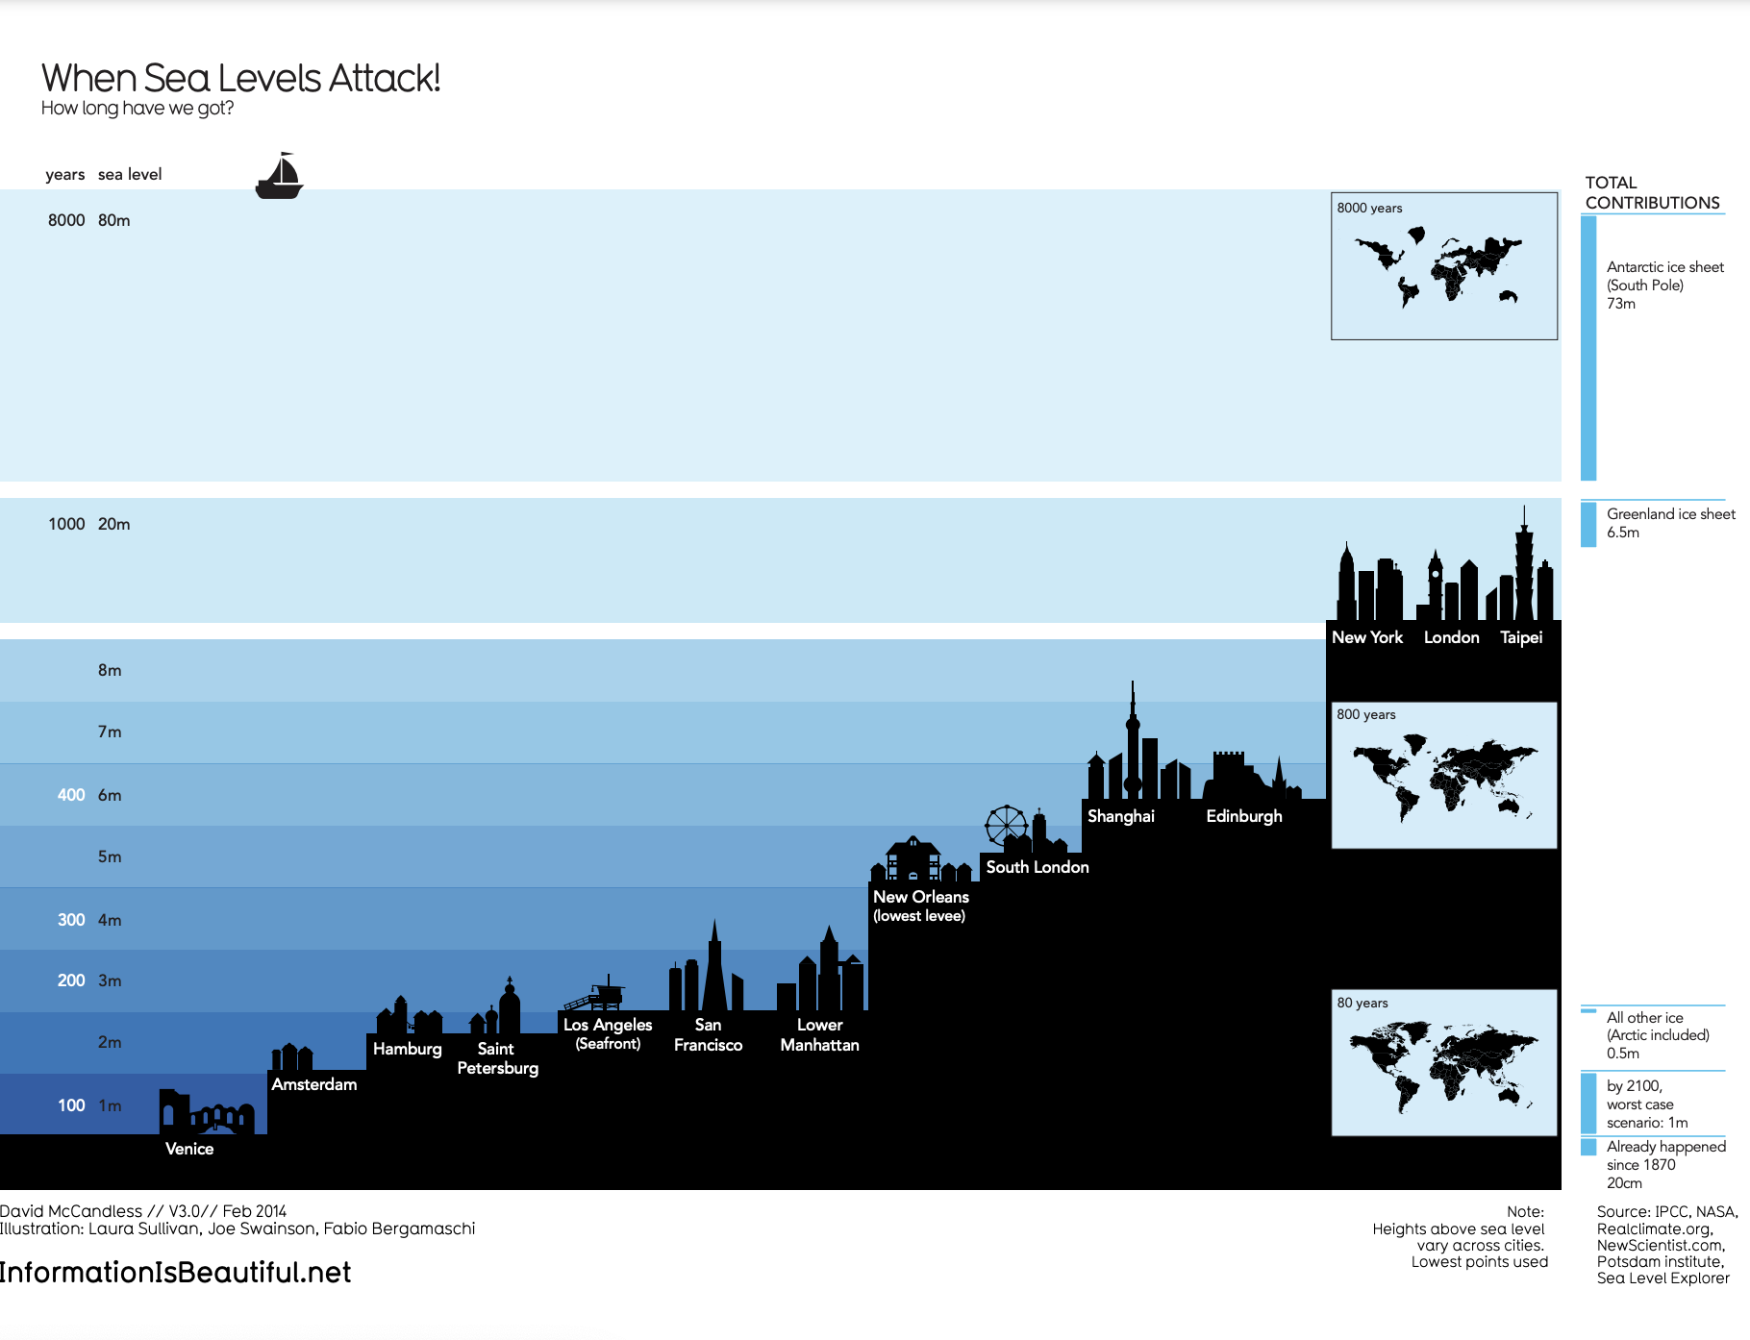

This visualization demonstrates how much sea levels are projected to rise over the course of 8,000 years. On the y-axis, it lists both the number of years and the sea level in meters. From right to left, starting with the lowest sea level, the chart includes silhouettes of different cities around the world to demonstrate how long it would take for most of the world to be underwater. It also includes inset maps of the continents and how they would appear at different times as sea levels continue to rise.

Save this data visualization as a .pdf by clicking the file below:

[IIB-LICENSED_Sea-Levels.pdf](https://d3c33hcgiwev3.cloudfront.net/5eB5YE1QSPSgeWBNUKj0MQ_64cb4212fa57404a9a1d0274cc8ae8ba_IIB-LICENSED_Sea-Levels.pdf?Expires=1714608000&Signature=G6LCKJsAIrbf9jASO00h6v5~1kTSeKv9P4U5DXNtHlyheRUxc2sq2SP~ri0lRBRHtslCrNxt5YrXq8KbnK5WDQjQqRQUfIHscgoKJh7-Hly2y3m2RGvFXBKluirX047H3~NJsYmW3zS7Bxz5PKBb-wcB7jTfeCp3kJ7mLJNymnE_&Key-Pair-Id=APKAJLTNE6QMUY6HBC5A)

### 

### **Examine the four elements**

This When Sea Levels Attack visualization illustrates how much sea levels are projected to rise over the course of 8,000 years. The silhouettes of different cities with different sea levels, rising from right to left, helps to drive home how much of the world will be affected as sea levels continue to rise. Here is how this data visualization stacks up using the four elements of successful visualization:

* **Information (data):** This visualization uses climate data on rising sea levels from a variety of sources, including NASA and the Intergovernmental Panel on Climate Change. In addition to that data, it also uses recorded sea levels from around the world to help illustrate how much rising sea levels will affect the world.
* **Story (concept):** The visualization tells a very clear story: Over the course of 8,000 years, much of the world as we know it will be underwater.
* **Goal (function):** The goal of this project is to demonstrate how soon rising sea levels are going to affect us on a global scale. Using both data and the visual form, this visualization makes rising sea levels feel more real to the audience.
* **Visual form (metaphor):** The city silhouettes in this visualization are a beautiful way to drive home the point of the visualization. It gives the audience a metaphor for how rising sea levels will affect the world around them in a way that showing just the raw numbers can’t do. And for a more global perspective, the visualization also uses inset maps.

## **Key takeaways**

Notice how each of these visualizations balance all four elements of successful visualization. They clearly incorporate data, use storytelling to make that data meaningful, focus on a specific goal, and structure the data with visual forms to make it beautiful and communicative. The more you practice thinking about these elements, the more you will be able to include them in your own data visualizations.

[DESIGN THINKING AND VISUALIZATIONS](https://www.coursera.org/learn/visualize-data/lecture/9v3UG/design-thinking-and-visualizations)

We've covered a lot of ground in our exploration of data visualizations. We've talked a lot about how your audience should be the focus when you are making decisions about charts, colors, space, labels and everything else that goes into a data viz. Now let's talk about design thinking. **Design thinking is a process used to solve complex problems in a user-centric way**.

When you bring design thinking into your work, you're trying to identify alternative strategies for your visualizations that might not be clear right away. You have to challenge your own thinking and explore different ways of approaching the problems and finding solutions. Airbnb is one example of a company that uses a design thinking approach to help their business grow. When the company, a vacation rental online marketplace, wasn't generating as much revenue as they wanted, they decided to start experimenting. Even though the data they collected and analyzed was valuable, they needed to look at their product through the eyes of the customer. They realized the photos of the places that customers were seeing just weren't very good, so they decided to help their customers replace the not so great photos with more professional looking ones. So they hired a photographer and went door to door to take professional photos of their New York City listings. In a week, the listings with these photos saw 2 to 3 times more bookings, and their revenue nearly doubled, thanks to their new design thinking, user based mindset. If design thinking can work for companies like Airbnb, it can help data analysts too, and data visualization is the perfect stage of your analysis to apply a user based mindset.

If you use design thinking when planning and creating your data viz, you'll be making decisions based on the needs of the people who will be viewing them. This way your audience will be engaged and enlightened by how you visualize your findings. While the **design thinking process comes in lots of different forms,** they all have stages or phases. **We'll talk about five phases that you can use when creating data visualizations: empathize, define, ideate, prototype, and test.** In the spirit of design thinking, these phases don't have to follow a set order. Instead, think of them as an overview of actions that can help you produce a user centered design in your visualizations.

In the **empathize phase** you think about the emotions and needs of the target audience of your data viz, whether it's stakeholders, team members or the general public. Here you should avoid areas where people might face obstacles interacting with your visualizations. For example, let's say you've been working on an analysis for a pharmaceutical company about how patients have been responding to a new treatment. You're getting ready to visualize the data, so you should think about the audience, which will include stakeholders like pharmacists, doctors and other medical professionals. Maybe you're thinking of using a color scheme that you like, but you realize that these colors might be a challenge to some people. The colors might be too bright or dramatic, which might not be right for the seriousness of the data. Or the colors might not have enough contrast for people who have color vision deficiencies.By adjusting the colors, you'll be empathizing with the needs of your audience.

If there's someone on your team who is vision impaired, you want to find a way to explain the data verbally as well. The **define phase** helps you to find your audience's needs, their problems, and your insights. This goes hand in hand with the empathize phase as you'll use what you learned in that phase to help you spell out exactly what your audience needs from your visualization. You could use this phase to think about which data to show in your visualization. Maybe this data viz will also be presented to patients who are part of your company's study. While you'll need to meet your objectives, there might be data that could make these people uncomfortable. You can think of ways to position that data to make it more digestible. Or if you're presenting to different audiences, you can adjust your visualizations to meet each group's needs by seeking input from members of the group or colleagues who've worked with that group before.

In the **ideate phase**, you start to generate your data viz ideas. You'll use all of your findings from the empathize and define phases to brainstorm potential data viz solutions.This might involve creating drafts of your visualization with different color combinations or maybe experimenting with different shapes. Creating as many examples as possible will help you refine your ideas. **The key here is to always remember your audience when coming up with ideas and strategies**. You want to think about how you can position your visualizations to meet the needs and expectations of your audience. The final two phases are prototype and test. Here you'll start putting your charts, dashboards or other visualizations together.

If you've kept your audience in mind through all the phases to this point, then your data viz will be informative and approachable. You might want to create lots of visualizations to choose which one best meets your objective.

You could test your visualizations by showing them to team members before presenting them to stakeholders. If you've created more than one for the same data, or for different audiences like the medical professionals and the patients from our earlier example, you can share all of your options.

As always, listen to any feedback you get. Critiques both your own and others are key to the design thinking process. They help you keep your focus on the audience by integrating new ideas in your final product.

The phrase thinking outside the box is used a lot, but it definitely applies here. The box in this case is your own usual way of approaching data, and its visualization.

If you embrace design thinking, you'll be able to create super effective data viz for any audience. Up next, we'll cover more things you need to consider within your data viz. See you there.

[[OPTIONAL] DESIGN THINKING FOR VISUALIZATION IMPROVEMENT](https://www.coursera.org/learn/visualize-data/supplement/ihlqt/optional-design-thinking-for-visualization-improvement)

Design thinking for data visualization involves five phases:

1. **Empathize:** Thinking about the emotions and needs of the target audience for the data visualization
2. **Define:** Figuring out exactly what your audience needs from the data
3. **Ideate:** Generating ideas for data visualization
4. **Prototype:** Putting visualizations together for testing and feedback
5. **Test:** Showing prototype visualizations to people before stakeholders see them

As **interactive dashboards become more popular** for data visualization, **new importance has been placed on efficiency and user-friendliness**. In this reading, you will learn how design thinking can improve an interactive dashboard. As a junior analyst, you wouldn’t be expected to create an interactive dashboard on your own, but you can use design thinking to suggest ways that developers can improve data visualizations and dashboards.

## 

## **An example: online banking dashboard**

Suppose you are an analyst at a bank that has just released a new dashboard in their online banking application. This section describes how you might explore this dashboard like a new user would, consider a user’s needs, and come up with ideas to improve data visualization in the dashboard. The dashboard in the banking application has the following data visualization elements:

* Monthly spending is shown as a donut chart that reflects different categories like utilities, housing, transportation, education, and groceries.
* When customers set a budget for a category, the donut chart shows filled and unfilled portions in the same view.
* Customers can also set an overall spending limit, and the dashboard will automatically assign the budgeted amounts (unfilled areas of the donut chart) to each category based on past spending trends.

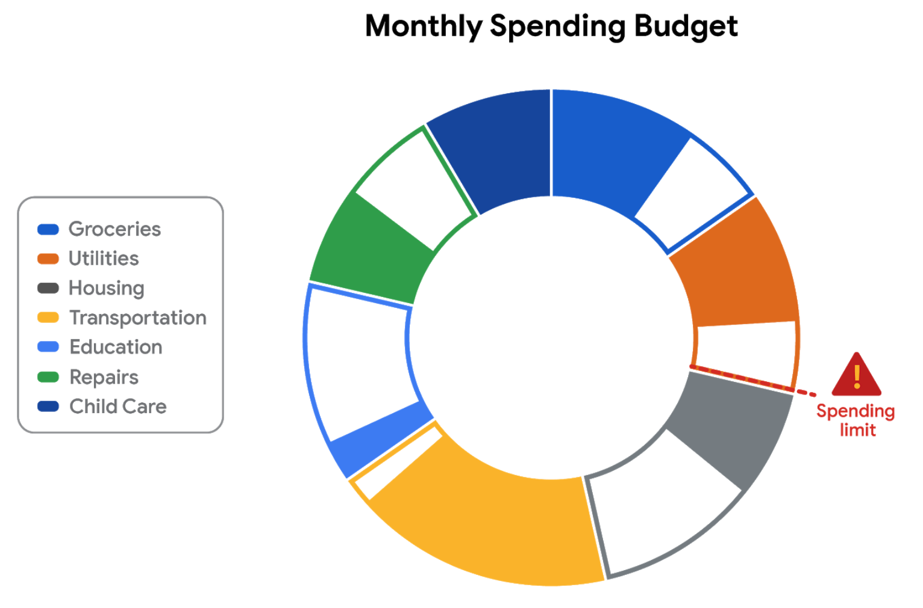

### **Empathize**

First, empathize by putting yourself in the shoes of a customer who has a checking account with the bank.

* Do the colors and labels make sense in the visualization?
* How easy is it to set or change a budget?
* When you click on a spending category in the donut chart, are the transactions in the category displayed?

What is the main purpose of the data visualization? If you answered that it was to help customers stay within budget or to save money, you are right! Saving money was a top customer need for the dashboard.

### **Define**

Now, imagine that you are helping dashboard designers define other things that customers might want to achieve besides saving money.

What other data visualizations might be needed?

* Track income (in addition to spending).
* Track other spending that doesn’t neatly fit into the set categories (this is sometimes called **discretionary spending**).
* Pay off debt.

Can you think of anything else?

### **Ideate**

Next, ideate additional features for the dashboard and share them with the software development team.

* What new data visualizations would help customers?
* Would you recommend bar charts or line charts in addition to the standard donut chart?
* Would you recommend allowing users to create their own (custom) categories?

Can you think of anything else?

### **Prototype**

Finally, developers can prototype the next version of the dashboard with new and improved data visualizations.

### **Test**

Developers can close the cycle by having you (and others) test the prototype before it is sent to stakeholders for review and approval.

## **Key takeaways**

This design thinking example showed how important it is to:

* Understand the needs of users.
* Generate new ideas for data visualizations.
* Make incremental improvements to data visualizations over time.

You can refer to the following articles for more information about design thinking:

* [Three Critical Aspects of Design Thinking for Big Data Solutions](https://dataconomy.com/2019/05/three-critical-aspects-of-design-thinking-for-big-data-solutions/)
* [Data and Design Thinking: Why Use Data in the Design Process?](https://www.enginess.io/insights/data-and-design-thinking)

VISUALIZATION CONSIDERATIONS

[PRO TIPS FOR HIGHLIGHTING KEY INFORMATION](https://www.coursera.org/learn/visualize-data/supplement/ewNyk/pro-tips-for-highlighting-key-information)

Headlines, subtitles, labels, and annotations help you turn your data visualizations into more meaningful displays. After all, you want to invite your audience into your presentation and keep them engaged. When you present a visualization, they should be able to process and understand the information you are trying to share in the first five seconds. This reading will teach you what you can do to engage your audience immediately.

If you already know what headlines, subtitles, labels and annotations do, go to the guidelines and style checks at the end of this reading. If you don’t, these next sections are for you.

## **Headlines that pop**

A **headline** is a line of words printed in large letters at the top of a visualization to communicate what data is being presented. It is the attention grabber that makes your audience want to read more. Here are some examples:

* [Which Generation Controls the Senate?](https://i.redd.it/rw0vrjakuoc61.png): This headline immediately generates curiosity. Refer to the [subreddit post](https://www.reddit.com/r/dataisbeautiful/comments/l1yly6/oc_which_generation_controls_the_senate/) in the dataisbeautiful community, r/dataisbeautiful, on January 21, 2021.
* [Top 10 coffee producers](https://ichef.bbci.co.uk/news/976/cpsprodpb/65D8/production/_100827062_chart-globalcoffeeproduction-iskhe-nc.png): This headline immediately informs how many coffee producers are ranked. Read the full article: [bbc.com/news/business-43742686](https://www.bbc.com/news/business-43742686).

Check out the chart below. Can you identify what type of data is being represented? Without a headline, it can be hard to figure out what data is being presented. A graph like the one below could be anything from average rents in the tri-city area, to sales of competing products, or daily absences at the local elementary, middle, and high schools.

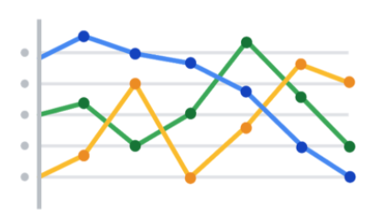

Turns out, this illustration is showing average rents in the tri-city area. So, let’s add a headline to make that clear to the audience. Adding the headline, “**Average Rents in the Tri-City Area**” above the line chart instantly informs the audience what it is comparing.

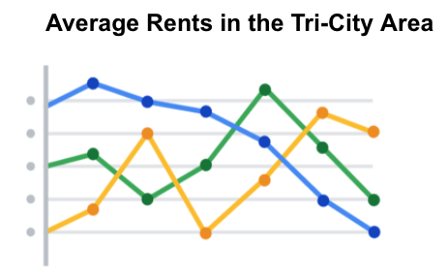

**Subtitles that clarify**

A **subtitle** supports the headline by adding more context and description. Adding a subtitle will help the audience better understand the details associated with your chart. Typically, the text for subtitles has a smaller font size than the headline.

In the average rents chart, it is unclear from the headline “**Average Rents in the Tri-City Area**”which cities are being described. There are tri-cities near San Diego, California (Oceanside, Vista, and Carlsbad), tri-cities in the San Francisco Bay Area (Fremont, Newark, and Union City), tri-cities in North Carolina (Raleigh, Durham, and Chapel Hill), and tri-cities in the United Arab Emirates (Dubai, Ajman, and Sharjah).

We are actually reporting the data for the tri-city area near San Diego. So adding “**Oceanside, Vista, and Carlsbad**” becomes the subtitle in this case. This subtitle enables the audience to quickly identify which cities the data reflects.

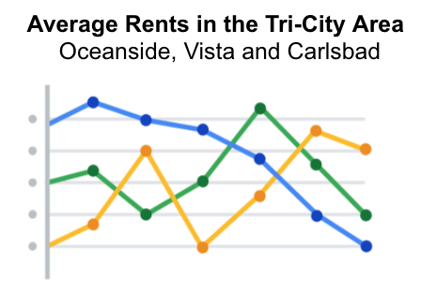

## **Labels that identify**

A **label** in a visualization identifies data in relation to other data. Most commonly, labels in a chart identify what the x-axis and y-axis show. Always make sure you label your axes. We can add “**Months (January - June 2020)**” for the x-axis and “**Average Monthly Rents ($)**” for the y-axis in the average rents chart.

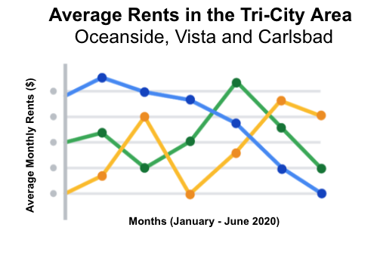

Data can also be labeled directly in a chart instead of through a chart legend. This makes it easier for the audience to understand data points without having to look up symbols or interpret the color coding in a legend.

We can add direct labels in the average rents chart. The audience can then identify the data for Oceanside in yellow, the data for Carlsbad in green, and the data for Vista in blue.

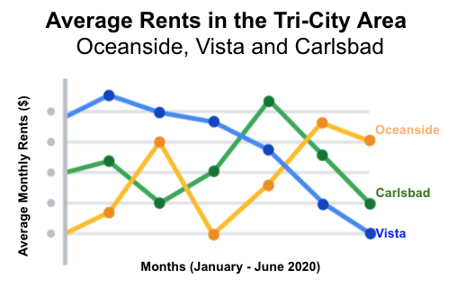

## **Annotations that focus**

An **annotation** briefly explains data or helps focus the audience on a particular aspect of the data in a visualization.

Suppose in the average rents chart that we want the audience to pay attention to the rents at their highs. Annotating the data points representing the highest average rents will help people focus on those values for each city.

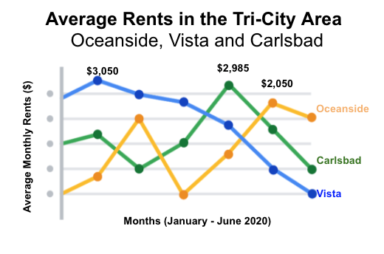

## **Guidelines and pro tips**

Refer to the following table for recommended guidelines and style checks for headlines, subtitles, labels, and annotations in your data visualizations. Think of these guidelines as guardrails. Sometimes data visualizations can become too crowded or busy. When this happens, the audience can get confused or distracted by elements that aren’t really necessary. The guidelines will help keep your data visualizations simple, and the style checks will help make your data visualizations more elegant.

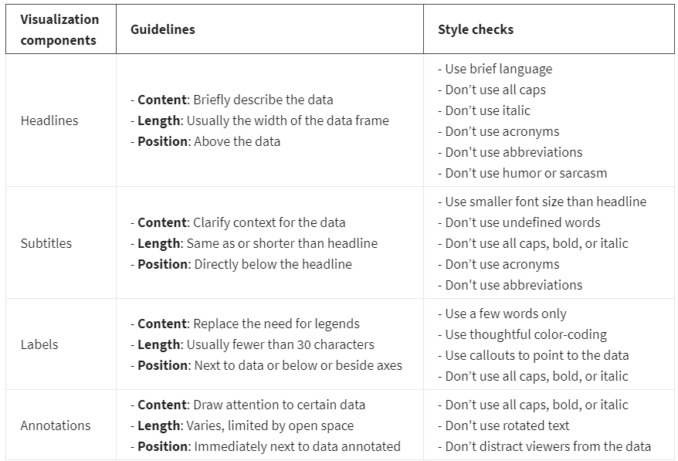

**Key takeaways**

You want to be informative without getting too detailed. To meaningfully communicate the results of your data analysis, use the right visualization components with the right style. In other words, let simplicity and elegance work together to help your audience process the data you are sharing in five seconds or less.

[ACCESSIBLE VISUALIZATIONS](https://www.coursera.org/learn/visualize-data/lecture/yVjKD/accessible-visualizations)

Hey, great to have you back, let's dive back in. **Over 1 billion people in the world have a disability.** That's more than the populations of the United States, Canada, France, Italy, Japan, Mexico, and Brazil combined. Before you design a data viz, it's important to keep that fact in mind.

Not everyone has the same abilities, and people take in information in lots of different ways. You might have a viewer who's deaf or hard of hearing and relies on captions, or someone who's color blind might look to specific labeling for more description. We've covered a lot of ways to make a data visualization beautiful and informative. And now it's time to take that knowledge and make it accessible to everyone, including those with disabilities.

**Accessibility** can be defined a number of different ways. Right from the start, there's a few ways you can incorporate accessibility in your data visualization. You'll just have to think a little differently, it helps to label data directly instead of relying exclusively on legends, which require color interpretation and more effort by the viewer to understand. This can also just make it a faster read for those with or without disabilities.

Check out this data viz, the colors make it challenging to read and the legend is confusing.

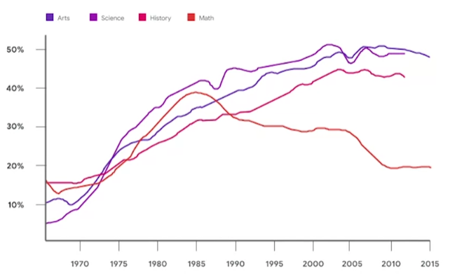

Now, if we just remove the legend and add in data labels, bam, you've got a clearer presentation.

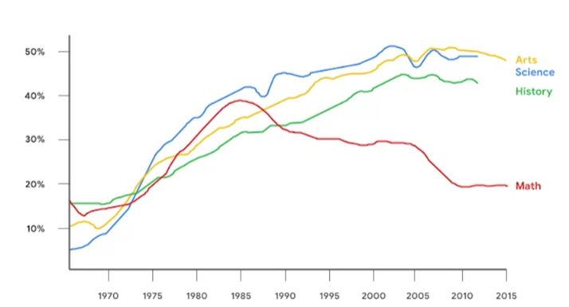

Another way to make your visualizations more accessible is to provide text alternatives, so that it can be changed into other forms people need, such as large print, braille, or speech.

**Alternative text** provides a textual alternative to non-text content. It allows the content and function of the image to be accessible to those with visual or certain cognitive disabilities. Here's an example that shows additional text describing the chart.

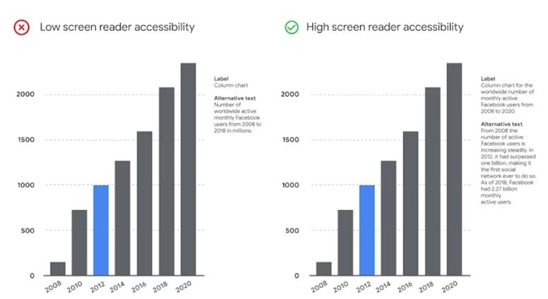

And speaking of text, you can make data from charts and diagrams available in a text-based format through an export to Sheets or Excel.

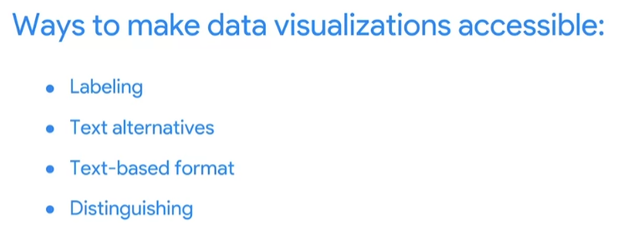

You can also make it easier for people to see and hear content by separating foreground from background.

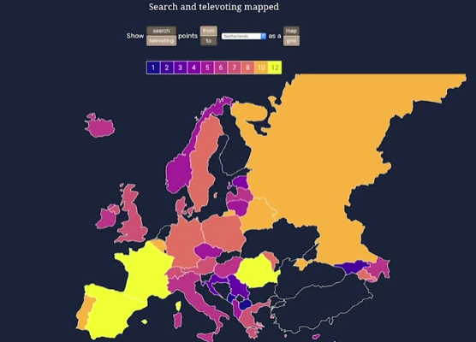

Using bright colors, that contrast against the background can help those with poor visibility, whether permanently or temporarily clearly see the information conveyed.

Another option is to avoid relying solely on color to convey information, and instead distinguish it with different textures and shapes.

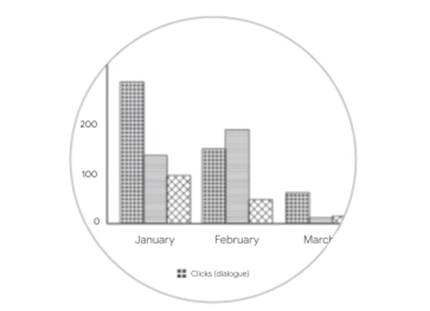

Another general rule is to avoid over complicating data visualizations.

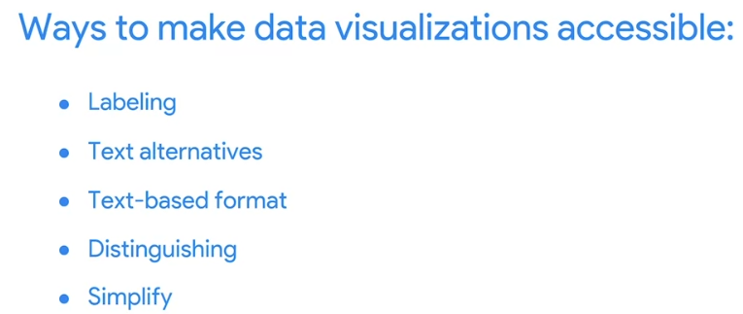

Overly complicated data visualizations turn off most audiences because they can't figure out where and what to focus on. That's why breaking down data into simple visualizations is key.

A common mistake is including too much information in a single piece, or including long chunks of text or too much information and graphs and charts.

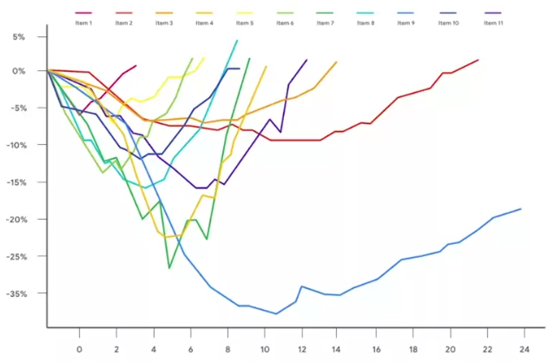

This can defeat the whole purpose of your visualization, making it impossible to understand at first glance. **Ultimately, designing with an accessibility mindset means thinking about your audience ahead of time**. Focusing on simple, easy to understand visuals, and most importantly, creating alternative ways for your audience to access and interact with your data. And when you pay attention to these details, we can find solutions that make data visualizations more effective for everyone. You've discovered the importance of creating data viz that cater to your audience while keeping focus on the objective. You also learned how to incorporate elements of science, art and even philosophy into your visualizations. Coming up we'll check out how to take all of these learnings and apply them in Tableau. You'll get to see how this data visualization tool makes your data viz work more efficient and effective.

[ANDREW: MAKING DATA ACCESSIBLE](https://www.coursera.org/learn/visualize-data/lecture/nGSKz/andrew-making-data-accessible)

Accessibility is really about making sure that you are creating data visualization, graphs, charts, tables, that anyone can interact with whether they have a long term or even as a temporary form of impairment.

It could be auditory, it could be visual, could be sensory in some way. Typically the ones we talked about in data visualization have to deal with color and contrast. Or maybe they can't see. So there's a number of things you can do with any visualizations as you're getting ready to show people and bring it out into the world.

To make it easier for them to understand your graph, and understand the points you're trying to make, and just to make yourself more inclusive, you're going to create this stuff and you're not going to be the one presenting it anymore. It's going to show up in a place where you won't be the one being able to navigate the data for people and frame it for people. And that's a good thing.

But as it moves further away from you, you also won't be there standing by it being able to explain it to people and be like, hey, here's the point, or, hey, maybe you can't read or see this or maybe these colors are confusing, let me make sure that you got the point clearly. It's just a way of making sure that everyone in the room is able to experience the thing you've worked so hard on and able to take away the point in a clear way that they too, can basically take action on the data that you spent all this time working with and making you know presentable for folks. So all these things, they're great for accessibility and they're more inclusive but they're also this making you a better data analyst and a better storyteller, because they force you to become more empathetic of your audience and who's receiving your data. You're making this to move the hearts and minds of other people to convince someone else that this data is meaningful to them and they should take action on it. Or they should know this and they should use this for the organization or for their lives or for whatever the thing may be. And so, by focusing on accessibility, by focusing on the audience, by making it more inclusive, you're making your data clear and more impactful for everyone.

[DESIGN A CHART IN 60 MINUTES](https://www.coursera.org/learn/visualize-data/supplement/IcuWb/design-a-chart-in-60-minutes)

By now, you understand the principles of design and how to think like a designer. Among the many options of data visualization is creating a **chart**, which is a graphical representation of data.

Choosing to represent your data via a chart is usually the most simple and efficient method. Let’s go through the entire process of creating any type of chart in 60 minutes. The goal here is to develop a prototype or mock up of your chart that you can quickly present to an audience. This will also enable you to have a sense of whether or not the chart is communicating the information that you want.

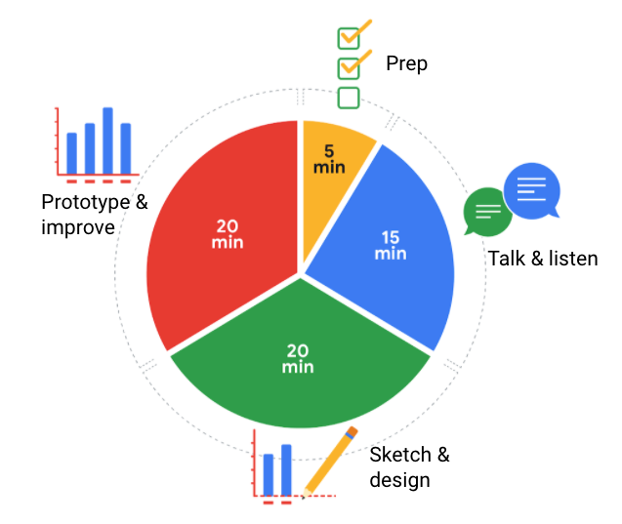

Follow this high level 60-minute chart to guide your thinking whenever you begin working on a data visualization.

**Prep (5 min):** Create the mental and physical space necessary for an environment of comprehensive thinking. This means allowing yourself room to brainstorm *how* you want your data to appear while considering the amount and type of data that you have.

**Talk and listen (15 min):** Identify the object of your work by getting to the “ask behind the ask” and establishing expectations. Ask questions and really concentrate on feedback from stakeholders regarding your projects to help you hone how to lay out your data.

**Sketch and design (20 min):** Draft your approach to the problem. Define the timing and output of your work to get a clear and concise idea of what you are crafting.

**Prototype and improve (20 min):** Generate a visual solution and gauge its effectiveness at accurately communicating your data. Take your time and repeat the process until a final visual is produced. It is alright if you go through several visuals until you find the perfect fit.

## 

## **Key takeaways**

This is a great overview you can use when you need to create a visualization in a short amount of time. As you become more experienced in data visualization, you will find yourself creating your own process. You will get a more detailed description of different visualization options in the next reading, including line charts, bar charts, scatterplots, and more. No matter what you choose, always remember to take the time to prep, identify your objective, take in feedback, design, and create

[HANDS-ON ACTIVITY: CREATE YOUR OWN VISUALIZATION](https://www.coursera.org/learn/visualize-data/quiz/nidlM/hands-on-activity-create-your-own-visualization)



## **Activity Overview**



Earlier in this course, you learned the importance of visualizing data with design thinking. In this activity, you will apply this knowledge and create your own visualization from a dataset.

By the time you complete this activity, you will be able to create and customize data visualizations using the Chart Editor in a spreadsheet. This will enable you to answer a business question with a shareable representation of data, which is important for presenting your findings in your career as a data analyst.



### Scenario

You are a junior data analyst at a local company. In your current data analysis project, you’ve been exploring sales data for all of your company’s products, including the top products and sales trends for the last year. You need to present the results of this analysis to the company executives. Your goal for this presentation is to demonstrate how sales of the company’s products have changed over the last 12 months.

Your findings about the two top-selling products include:

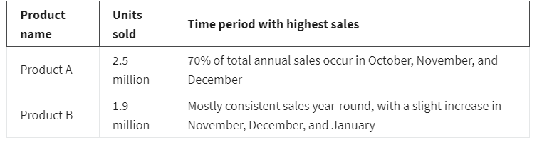Your audience is made up of the chief marketing officer (CMO) and marketing department vice presidents (VPs), not other data analysts or engineers. They will use the information you present to make decisions on how to allocate advertising dollars for each product for the coming year.

### 

### **Step 1: Access the dataset**

To get started, first access the example dataset.

Click the link to the example dataset to create a copy. If you don’t have a Google account, you may download the example dataset directly from the attachments below.

Link to example dataset: [Making your own visualization](https://docs.google.com/spreadsheets/d/1Zhm9WyrM4dmBav9Vc1VnCU82vLlESEaJGFgNcfTRsZk/template/preview)

OR

Download example dataset:

[Making your own visualization - example dataset](https://d3c33hcgiwev3.cloudfront.net/NQchTAEVRoaHIUwBFbaG8w_83656977ed1b4900879d1c24ac1602d4_Making-your-own-visualization---example-dataset.xlsx?Expires=1714780800&Signature=PX1VRcoRtkFVY9mTVxON4FltnH0xvR2gMEAKnGl56L3ceM5mwHQC-53TOBnC-paL5iIV-rQeaWK1Et31SflXR-zDPEpeF~gO7HliU9MXTOY~CmyykjBIfoM~Wum0Y1iNk0ZBQ6l0PS4LlatjRlQMDnbsf4lpWmOWMmcuIxZY0-Y_&Key-Pair-Id=APKAJLTNE6QMUY6HBC5A)

### **Step 2: Review the design thinking process**

Now that you are familiar with the scenario, take a moment to review the steps of the design thinking process. Remember, design thinking is about keeping a user-centric focus. By understanding the needs of your audience, you can craft a data visualization that communicates your findings effectively. The steps of the Design Thinking process are:

* Empathize: Think about the emotions and needs of the target audience.
* Define: Understand the audience’s needs, problems, and insights.
* Ideate: Use your findings from the previous phases to begin to create data visualizations.
* Prototype: Start putting it all together. In this case, you can put your findings into a presentation or dashboard.
* Test: Check that your prototype is effective. In this case, you can show your visualizations to team members before the presentation.

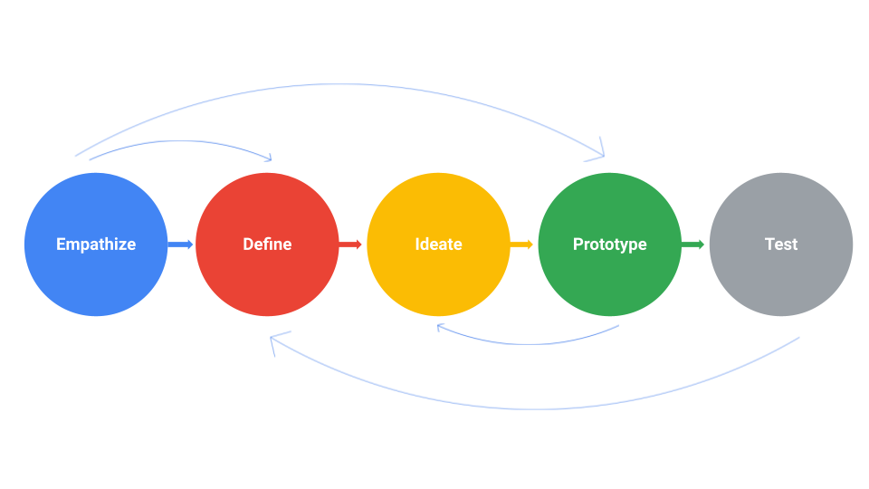

Take a moment to empathize with your audience’s needs. What takeaways are most important to them? Which data visualization would communicate that takeaway most effectively?

As you consider which kinds of data visualizations would be most useful, review the decision tree from earlier in this course. This will help you figure out what type of story you want to tell with your data.

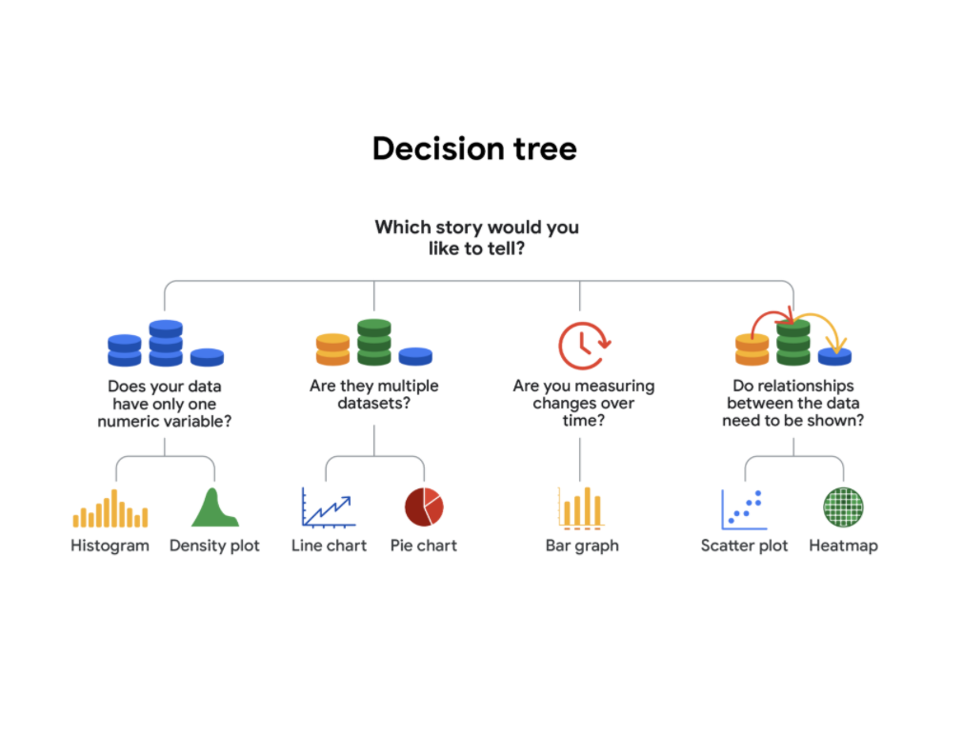

-Does your data have only one numeric variable? Histogram or Density plot

-Are there multiple data sets? Line chart or pie chart

-Are you measuring changes over time? Bar chart

-Do relationships between the data need to be shown? Scatter plot or heatmap

### 

### **Step 3: Create a prototype**

Now, use spreadsheet software to try out different visualizations of the data.

1. Highlight all cells by clicking on cell A1 and dragging to M3. This should highlight all the data and headers aside from the Total column.

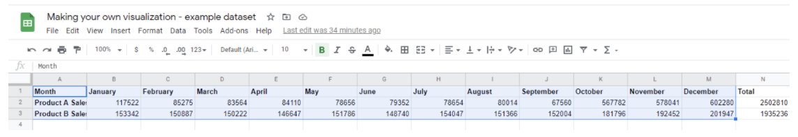

2. Click on the Insert tab and select Chart.

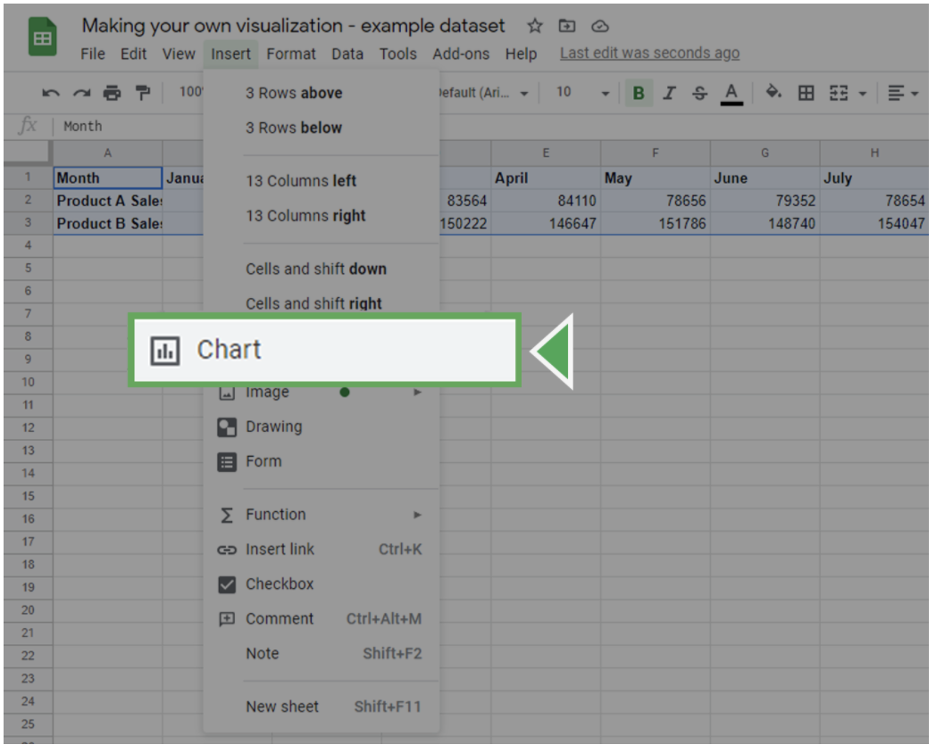

This will insert a chart object and bring up the Chart editor on the right side of the screen.

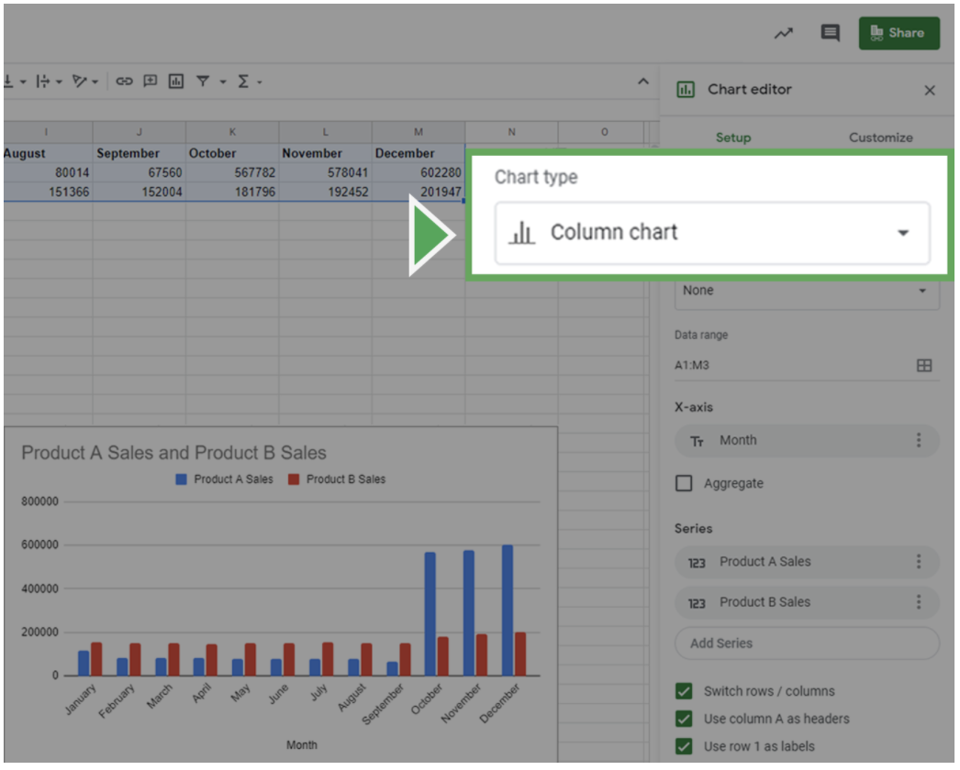

3. In the Chart editor, click on the Setup tab.

4. Click on the Chart type dropdown box. This will bring up the different kinds of charts you can create. Select the data visualization you think would be most useful during your design thinking process.

### **Step 4: Customize your chart**

Now, customize your visualization by editing the titles, labels, and style.

Click on the Customize tab in the Chart Editor. Click on the Chart & axis titles dropdown to add an informative title or label your axes. Click the Legend dropdown to create a legend for your chart.

Once you decide on the style and labels, focus on the design elements of the chart. This is your chance to adjust elements such as color and font. For instance, you can change the color scheme of the chart in the Chart Style dropdown.

When creating data visualizations, accessibility is important. Set up your visualization in a way that is accessible and understandable by including highly contrasting colors.

Once you’re done customizing your chart, review your choices to ensure that your visualization is easy to understand.

* Do you think your audience will fully understand what they are observing within five seconds?
* Will they understand the key takeaway you’re trying to communicate after another five seconds?
* Did you use the most clear and communicative visualization style for your data?

If the answer to any of these questions is no, try different visualization styles and design choices. Experiment with colors, shapes, and chart types to find what makes it easier or harder to understand the message you are trying to convey.

[TEST YOUR KNOWLEDGE ON EXPLORING DATA VISUALIZATIONS](https://www.coursera.org/learn/visualize-data/quiz/wDQkr/test-your-knowledge-on-exploring-data-visualizations)

M1 CHALLENGE

### [GLOSSARY TERMS FROM MODULE 1](https://www.coursera.org/learn/visualize-data/supplement/uajvO/glossary-terms-from-module-1)